Analysis of the Problem

Description of Problem
The objective of this project is to develop a game called Flappy Bird. This endless bird game will involve a bird character soaring through dynamically generated vertical poles that contain gaps for the bird to pass through. The game will end if the player’s bird collides with any of the poles or if the bird touches the water.Key features include a straightforward text-based input system for capturing player name and age, with real-time validation to ensure accurate data entry and also includes player data storage and progressional tracking.
The target users for this game are individuals who can operate a computer, making the interface intuitive and accessible for players of various ages. The game will integrate with a SQL database to store individual player data such as player name, age, high score, retries, and level achieved.
This project aligns with the Advanced Higher Computing Science requirements because it incorporates a user-friendly interface and validates inputs, ensuring robustness. Additionally, a bubble sort algorithm will be used to sort the scores, allowing efficient organization of high scores and to show the highest score achieved by the player, adding a competitive element for players.

Scope
The scope of my project will include:
1.A completed design, data dictionary, query design, wireframes showing the game UI and UML case diagram to show the details of the users and their interaction with the game development.
2.A working game with fully functional database to record data of individual players 3. Test plans with extreme, exceptional, and normal test data to handle any unexpected inputs.Description of test cases and the expected outputs of my program.
4.Implementation of an bubble sort algorithm to organize scores efficiently, displaying
the highest score
5.The software specification and the results of final testing.
6.An evaluation report.

Constraints
The technical, time and economic constraints are listed below:
- The game will be coded in python as I have the most experience working with python
- Pygame is imported into my project because I cannot create a game using only the
Python language.
- MySQLconnector is also imported in my project to connect my game to the database
and execute queries via my source code.
- There will be no economic costs involved for the development of my project because
I am using visual studio to code my project which is an open-source free to use software
6. The project also relies on freely available libraries and tools, avoiding any additional
expenses.
5. I will ensure that my project is completed by the deadline of 29th March as it will need
to be delivered to SQA for marking. The submission deadline is 4th April 2019

Boundaries
1. The system will prompt the player for their name and age once per session. The
player has unlimited retries if they fail the initial input attempt.
- The age must also be less than or equal to 120 to prevent errors due to unrealistic
inputs.
- The age must have numeric characters only and must be equal to or greater than 8.
- The email must have an “@” and “.” in it for input validation 5. The player name input should have a maximum limit (e.g., 20 characters) to avoid overly long names that may cause display issues in the database

UML Use Case Diagram
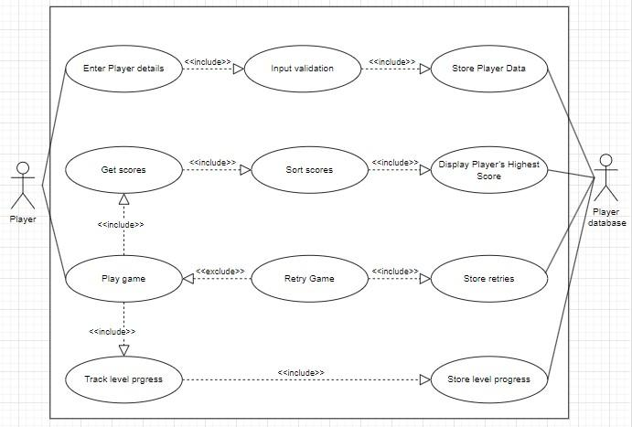

Requirement Specification
Flappy Bird is a game created for users who love a challenging and exciting game that has a lot of competitive aspects to it .The game aims to entertain players by challenging them to achieve high scores which is sent to a database to compare other high scores of different players further enhancing the competitive aspect.

Functional requirements
1.The game must allow the bird to fall naturally due to gravity unless the player presses
the mouse button or the spacebar to make it ascend.
2.Display the bird, poles, and ground.
3.Animate the bird's flapping and falling.
4.The game will provide a main menu and a game-over screen.
5.The game must generate poles with a fixed gap at regular intervals.
6.After a collision is detected the game must show the death screen with the “Retry” button.
7.The game constantly checks for collisions between player and the vertical poles
during the game to display the game-over phase.
- The game asks for player’s details such as player name,email,age. The game
records high scores,retries and level for each individual player.
- The game will validate keyboard inputs, which are the player's name, email, and age. 10.The current score will be displayed during the gameplay, along with the level and
speed of the obstacles thus allowing players to track their progress.
11.The game tracks the user's score everytime the user dies the score is stored in the
scores array.
12.The game will implement a “partial” bubble sort algorithm on the scores array and the highest score is displayed using the “partially” sorted score’s array.(Partial bubblesort explained later in evaluation).
13.The game will allow players to retry when they collide with the vertical poles or touch
the ground in-game.
14.As the game progresses, the speed of the vertical poles shall increase up to a
predefined maximum speed limit.
15.The game must display the game menu with instructions and with the “Start” button.
16.The game must connect to a player database hosted on your pc.
17.A query is created to generate the player details table. 18.A SELECT query is created to find matching records of an existing player to modify
his details for update query
19.A UPDATE query is created to update the highscores of the player if his current
highscore is greater than his previous highscore
20.A INSERT query is created to insert the player details if player records do not exist.

End-User requirements
I have gathered information on the aspects that the end users want in the flappy bird game which is listed below:
1.Inputs that are taken must have input validation, should provide clear instructions,
validation messages for empty or incorrect fields.
2.The user-interface must be clear enough to understand the controls and mechanics
without needing detailed instructions.
3.The game should become progressively challenging over time. 4.Players should be able to see their current score and high score, allowing them to
track their progress and set goals for improvement.
5.Players should have the option to retry the game immediately if they collide with an
obstacle or fall in water.

Inputs,Processes and Outputs
Inputs:
Player Name
Age
Email
[Player key inputs] Processes:
1.Players sign up or login
1.Name input must have no special characters, at least 4 characters, and a maximum
of 20 characters.
2.Age input must be a number from 8 to 120 and must contain only a number .
3.Both name and age must not be left blank.
4. Email validation must be rigid including checking for empty spaces and presence of “@” and “.” etc.
2.Gameplay
1.Display the bird with the start screen and look for player input to start the game. 2.Detect collision between the bird and poles or water to end the game
3.Update and display the score as the bird moves and avoid the obstacles.
3.Collision
1.If an collision is found the game ends immediately and add the score to the scores
array.
2.The scores array is sorted out using bubble sort in descending order. 3.Since the score is sorted the highest score is the first element which is extracted and displayed as the high score in the death screen.
4.Retry Prompt
1.The player can retry if needed and the number of retries will also be stored. 2.If the player decides to retry and the game starts as it was in its initial state which includes the obstacles speed and the score
5.Database Interaction
1.After the collision has occurred between player and the poles the player data is
sent to the database.
2.If the player ends the pygame session the highest score is updated in the database
for the individual person.
3.If the same person starts a new session with the same player name,age and email their scores and high score is just updated instead of creating a new record.
Outputs:
1.Real-time score,Level and display during gameplay.
2.Retry prompt with options after a collision.
3.Immediate feedback for invalid inputs.
4.Displays options after a collision to either retry or exit.
5.Bird, Poles and water(ground).

Project Plan
The list of tasks with their allocation time is shown below:
Task | Sub Task | Duration | Start Date | Target Date
Analysis | Write the description of the project | 1 day | 1st Nov | 1st Nov
 | Write the scope and  Constraints of the project | 2 days | 2nd Nov | 3rd Nov
 | Write the Boundaries of the project | 1 day | 3th Nov | 3th Nov
 | Create an UML case diagram for the project | 1 day | 4th Nov | 4th Nov
 | Create the requirement specification and write the functional requirement. | ½ day | 5th Nov | 5th Nov
 | Write the End user requirement | ½ day | 6th Nov | 6th Nov
 | Create the project Plan for the Project | ¼ day | 7th Nov | 7th Nov
Design | Create wireframes for user interface | 2 days | 18th Nov | 20th Nov
Task | Sub Task | Duration | Start Date | Target Date
 | Create UML class diagram | 1 day | 20th Nov | 21th Nov
 | Pseudocode | 6 days | 1th Dec | 6th Dec
 | Query Design | 1 day | 7th Dec | 7th Dec
 | Data dictionary | 1 day | 10th Dec | 10th Dec
Implemen-  tation | Creating User Interface | 3 days | 13th Dec | 16th Dec
 | Creating Bird class and  Player logic | 5 days | 16th Dec | 22th Dec
 | Create Pole class and sorting logic | 3 days | 23th Dec | 26th Dec
 | Create overall logic including collision,start and retry buttons | 8 days | 26th Dec | 5th Jan
 | Create database and query logic in SQL and integrate to python | 5 days | 5th Jan | 11th Jan
 | Complete documentation and log of testing | 3 days | 11th Jan | 14th Jan
Testing | Comprehensive test plan | 4 days | 27th Jan | 1st Feb
 | Complete persona and test case | ½ day | 2nd Feb | 2nd Feb
 | Implement test plan and write results of testing | 4days | 3rd Feb | 6th Feb
Evaluation

Resources Required
The resources needed for each stage of development is shown below :

Analysis | Google docs online  Google Chrome  Microsoft Planner
Design | Google docs online  Scholar(Google Chrome)  Draw.io (UML Case Diagram)  Paint (User Interface)
Implementation | Visual Studio 2022/Visual Studio Code  XAMPP Control Panel (SQL and Apache for database)  Google Chrome  Google docs online
Testing | Visual Studio Code/Visual Studio 2022  Google Chrome  XAMPP Control Panel (SQL and Apache for database) Google docs online
Evaluation

Design of the Solution

User-Interface Design
Input validation interface
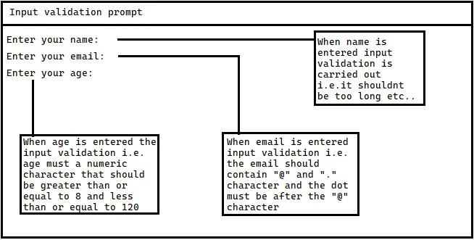

Game-menu Interface
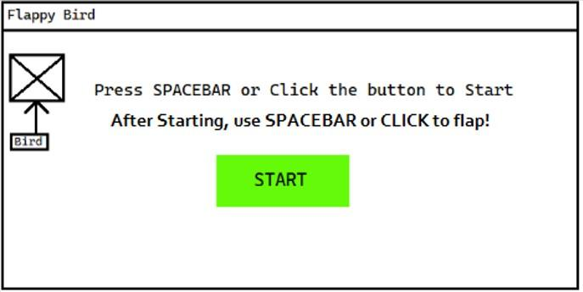
Game-active Interface
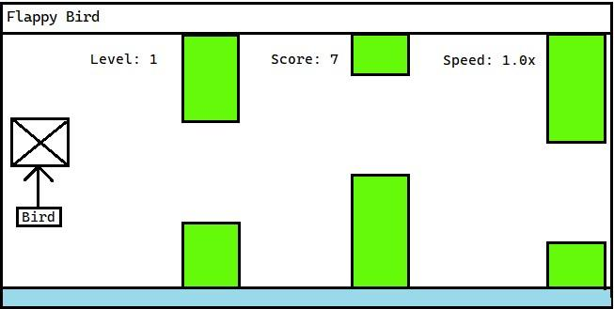

Game-over/Retry Interface
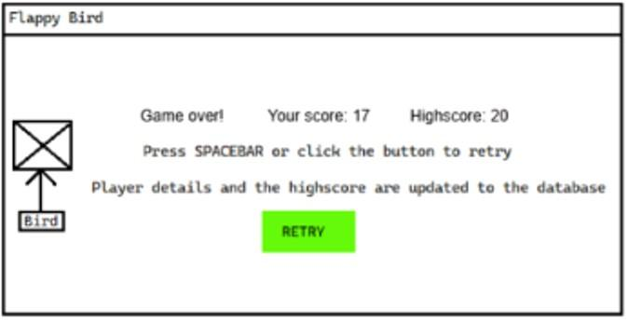

UML Class Diagram
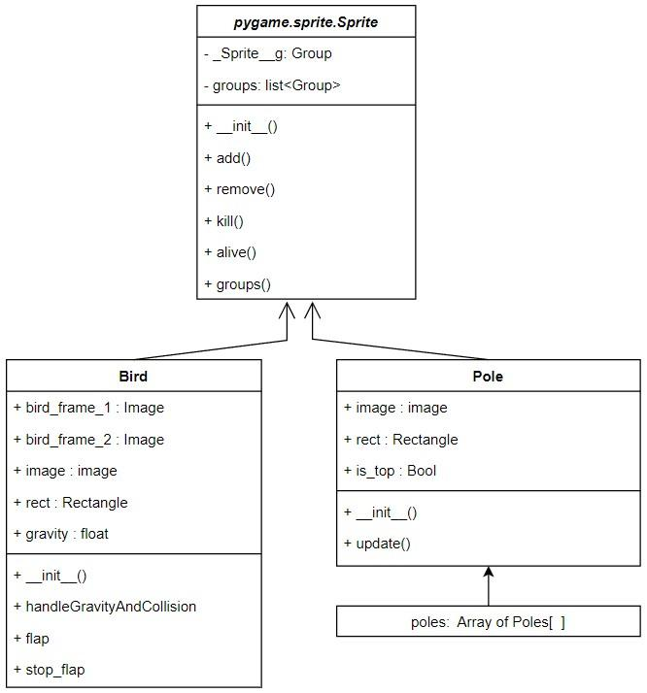
The pygame.sprite.Sprite class is an inbuilt class in the pygame library designed for objects with attributes like Image and rect (Rectangle).The Bird and Pole subclasses inherit from the parent class pygame.sprite.Sprite to use the attributes.

Pseudocode
#This Function that checks for input validation on name,email and age_input
FUNCTION Input_validation():
WHILE True: ㅤ name = INPUT(“Enter your name: ”) ㅤ TRIM name BY REMOVING STARTING AND LEADING TRAILS ㅤ IF length(name) >= 20: ㅤ ㅤ SEND “Name must be less than 20 characters TO DISPLAY”
ㅤ ㅤ ㅤ SKIP ITERATION ㅤㅤ ㅤ ㅤ ㅤ ㅤ ㅤ ㅤ ㅤ ㅤ ㅤ IF name IS BLANK: ㅤ ㅤ ㅤ SEND “Name cannot be blank” TO DISPLAY ㅤ ㅤ ㅤ SKIP ITERATION ㅤ ㅤ email = INPUT(“Enter your email: ”) ㅤ ㅤ TRIM email BY REMOVING STARTING AND LEADING TRAILS ㅤ ㅤ IF "@" is not in email OR "." is not in the part of email after "@": ㅤ ㅤ ㅤ SEND “Please enter a valid email address” TO DISPLAY
ㅤ ㅤ ㅤ SKIP ITERATION
ELSE: ㅤ local_part = EXTRACT the words before “@” ㅤ domain = EXTRACT the words after “@” ㅤ IF “.” not in domain or domain starts with “.” or ends with “.”: ㅤ ㅤ SEND “Please enter a valid email address” TO DISPLAY ㅤ ㅤ SKIP ITERATION ㅤ IF local_part is empty or “ ” in local_part: SEND “Please enter a valid email address” TO DISPLAY
SKIP ITERATION ㅤ FOR checkempty IN [Extract words before and after “.” in domain]:
IF checkempty IS EQUAL TO “” ㅤ SEND “Please enter a valid email address” TO DISPLAY
ㅤ ㅤ ㅤ SKIP ITERATION ㅤ ㅤ age_input = INPUT(“Enter your age: “) ㅤ ㅤ TRIM age_input BY REMOVING STARTING AND LEADING TRAILS ㅤ ㅤ IF age is not a digit: ㅤ ㅤ ㅤ SEND “Age must be a valid number” TO DISPLAY ㅤ ㅤ ㅤ SKIP ITERATION ㅤ ㅤ AGE = CONVERT age FROM STRING TO INTEGER ㅤ ㅤ IF age < 8 or age > 120:
ㅤ ㅤ ㅤ SEND “Age must be at greater than or equal to 8 but less than or equal to ㅤ
ㅤ ㅤ ㅤ 120” TO DISPLAY ㅤ ㅤ ㅤ SKIP ITERATION ㅤ ㅤ RETURN name,email,age END WHILE LOOP END FUNCTION
#Function that sorts the scores array when the player gets a new score
FUNCTION Partial_BubbleSort(scores):
#This function has “partial” bubble sort because unlike regular bubble sort it doesn't sort the whole array but performs a single pass of Bubble sort to move the highest score to the front. This design is intentional because after the player dies, the score is moved to where it's required rather than sorting the whole array. ㅤ swapped = True ㅤ n = length(scores) ㅤ WHILE swapped == True:
ㅤ ㅤ swapped = False ㅤ ㅤ FOR LOOP i FROM 0 TO n-1: ㅤ ㅤ IF scores[i] < scores[i+1]:
ㅤ ㅤ ㅤ SET scores[i],scores[i+1] TO scores[i+1],scores[i] ㅤ ㅤ RETURN scores #The score is returned early as it just sorts a single pass
END FUNCTION
name,age,email = CALL METHOD input_validation()
IMPORT pygame
IMPORT mysql.connector IMPORT random
#This function establishes a connection to the local database server and creates
a database if it doesn't exist FUNCTION create_connection(): ㅤ SET mydatabase,mycursor AS GLOBAL VARIABLES ㅤ SET mydatabase = mysql.connect( ㅤ host = “localhost”, ㅤ user = “root” ㅤ password = “” ㅤ )
ㅤ DECLARE CURSOR BY mydatabase.cursor TO UPDATE AND EDIT RECORDS ㅤ mycursor.execute query(“CREATE DATABASE IF NOT EXISTS Playerdatabase”)
NAME OF mydatabase IS “Playerdatabase” ㅤ
mycursor.execute QUERY FOR INITIALIZATION( “““
CREATE TABLE IF NOT EXISTS playerdetails( player_id INT AUTO_INCREMENT PRIMARY KEY, name VARCHAR(255), age INT, email VARCHAR(255),
ㅤ highscore INT, ㅤ level INT, ㅤ retries INT ㅤ ””” )
END FUNCTION
CALL METHOD create_connection()
#This function Updates or inserts player data everytime the player dies FUNCTION update_or_insert_records(name,age,email,highscore,level,retries): ㅤ query = “SELECT player_id,highscore FROM playerdetails WHERE name = %s ㅤ
ㅤ AND age = %s AND email = %s"
ㅤ EXECUTE THE QUERY ABOVE WITH ESCAPE VALUES(query,(name,age,email)) ㅤ FETCH THE RESULT ROW BY result = mycursor.fetchone() ㅤ IF result HAS ONE RESULT DO :
ㅤ ㅤ player[id] = FIRST ELEMENT OF THE TUPLE result ㅤ ㅤ previous_highscore = SECOND ELEMENT OF THE TUPLE result ㅤ ㅤ IF highscore > previous_highscore:
ㅤ ㅤ ㅤ update_query = “UPDATE playerdetails SET highscore = %s,level = ㅤ ㅤ
ㅤ ㅤ ㅤ %s,retries = %s WHERE player_id = %s” ㅤ ㅤ EXECUTE THE QUERY ABOVE WITH ESCAPE VALUES TO PREVENT ㅤ ㅤ
ㅤ ㅤ SQL INJECTION(query,(highscore,level,retries,player_id)) ㅤ ELSE :
ㅤ ㅤ insert_query = "INSERT INTO playerdetails ㅤ ㅤ ㅤ ㅤ ㅤ ㅤ ㅤ
ㅤ ㅤ (name,age,email,highscore,level,retries) ㅤ ㅤ VALUES (%s,%s,%s,%s,%s,%s)" ㅤ ㅤ ㅤ ㅤ
ㅤ ㅤ EXECUTE THE QUERY ABOVE WITH ESCAPE VALUES TO PREVENT ㅤ ㅤ
ㅤ ㅤ SQL INJECTION(insert_query,(name,age,email,highscore,level,retries)) ㅤ mydatabase.commit() #Saves all changes made to the database
#Bird class represents the player so it handles the appearance,movement and collision mechanics of the player. The bird or the player “character” can be controlled using this class.
CLASS Bird INHERITS pygame.sprite.Sprite:
CONSTRUCTOR __init__(SELF): #Constructor for Bird class ㅤ ㅤ CALL SUPER CONSTRUCTOR ㅤ ㅤ DECLARE SELF.bird_frame_1 INITIALLY “flapping image” ㅤ ㅤ DECLARE SELF.bird_frame_2 INITIALLY “normal image” ㅤ ㅤ DECLARE SELF.image INITIALLY bird_frame_2 ㅤ ㅤ DECLARE SELF.birdrect TO image.create_rectangle(position x,y) ㅤ ㅤ DECLARE SELF.gravity INITIALLY 0 ㅤ END CONSTRUCTOR
ㅤ #This function implements gravity on the bird and checks for collision with the
ㅤ ground if a collision is detected true is returned else false ㅤ FUNCTION handleGravityAndCollision(SELF): ㅤㅤ IF game_active is True: ㅤ ㅤㅤ INCREMENT SELF.gravity BY 0.35 ㅤ ㅤ ㅤ INCREMENT SELF.rect.y BY SELF.gravity ㅤ ㅤ IF SELF.rect.bottom >= 420: ㅤㅤ ㅤ SET SELF.rect.bottom TO 420 ㅤㅤ ㅤ RETURN True ㅤ ㅤ RETURN False ㅤ END FUNCTION
ㅤ FUNCTION flap(SELF): #This function contains code to allow the bird to flap ㅤ ㅤ IF game_active is True: ㅤ ㅤ ㅤ SET SELF.gravity = -5.75 ㅤ ㅤ ㅤ SET self.image TO SELF.bird_frame_1 #(Flapping Image) ㅤ END FUNCTION
ㅤ FUNCTION stop_flap(SELF): #This function contains code to reset flap image ㅤ ㅤ SET SELF.image TO SELF.bird_frame_2 #(Normal image) ㅤ
ㅤ END FUNCTION
END CLASS
#Pole class is responsible for npc (non-player controlled) “characters” which are the poles that the bird has to escape in order to survive.This class is responsible for movement,collision and appearance.
CLASS Pole INHERITS pygame.sprite.Sprite: CONSTRUCTOR __init__(SELF,x,y,Is_Top): #Constructor for Pole class ㅤ CALL SUPER CONSTRUCTOR ㅤ DECLARE SELF.image INITIALLY “Pole_bottom” #Sets image for bottom pole ㅤ IF Is_Top == True: ㅤ ㅤ SET SELF.image TO “Pole_Top” #Sets image for top pole ㅤ CREATE RECTANGLE AS SELF.rect WITH POSITION x,y FOR THE Bird image
ㅤ SET SELF.speed = 5 AS INITIAL POLE SPEED END CONSTRUCTOR

ㅤ # This function updates the position of the pole and removes it from the game
ㅤ if it moves off-screen. ㅤ ㅤ FUNCTION update(SELF):
ㅤ ㅤ IF game_active == True:ㅤ ㅤ ㅤ
ㅤ ㅤ ㅤ #As the game progresses the speed multiplier and speed is increased
ㅤ ㅤ ㅤ SELF.rect.x -= 5 * speed_multiplier ㅤ ㅤ ㅤ IF SELF.rect.right < 0: ㅤ ㅤ ㅤ ㅤ SELF.kill() #Pole is removed if it goes out of the screen
ㅤ END FUNCTION
END CLASS
INITIATE PYGAME
SCREEN = SET SCREEN DISPLAY(900,450) #900 pixels horizontal and 450 vertical
SET GAME NAME AS ‘Flappy Bird’
SET clock TO create_clock()
DECLARE water_surf INITIALLY “Water” #Water image
#The single bird group is used for player character
CREATE bird GROUP AS SPRITE.GROUPSINGLE()
ADD Bird CLASS INSTANCE TO THE SINGLE bird GROUP
#This array contains a list of pole objects to spawn infinite instances. Because
using a "Group" wouldn't meet the project requirements. object_list = [] scores= [] #The scores array captures the player's score upon death
#This constant determines the gap size between the top and bottom poles
SET GAP_SIZE = 600
#This constant determines where the pole starts from in the screen
SET POLE_X_START = 950
#This constant determines the minimum offset from the centre of the screen
where the pole can go SET POLE_Y_MIN = 75
#This constant determines the maximum offset from the centre of the screen
where the pole can go SET POLE_Y_MAX = 300
SET game_active = False #This variable defines the game active state
SET game_over = False #This variable defines the game over state
SET score_reset_time = 0 #Tracks the start time for the score calculation
SET level = 1 #This variable keeps track of player level and updates it
SET retries = 0 #This variable counts the number of retries the player makes
SET speed_multiplier = 1 #This variable keeps track of the pole speed SET next_level_score = 10 #This variable keeps count of the next score needed to
increase the level and speed_multiplier
SET score_recorded = False #This variable ensures that player’s score is
recorded only once per game session
SET sorted = False #This variable ensures score is sorted once
SET highscore = 0 #This variable stores the highscore
#This function creates top and bottom poles with a random gap, adjusts their
positions, and adds them to the obstacle list. FUNCTION create_poles():
ㅤ Gap_y = GENERATE A RANDOM NUMBER BETWEEN POLE_Y_MIN AND ㅤ
ㅤ POLE_Y_MAX ㅤ CREATE top_pole WITH THE FOLLOWING CHARACTERISTICS: ㅤ ㅤ X-COORDINATE = POLE_X_START
ㅤ ㅤ Y-COORDINATE = gap_y - (GAP_SIZE / 2) - 330 #The 300 constant is only ㅤ ㅤ for the top pole because for the top pole the image is bigger to prevent players
ㅤ from going over the poles and storing invalid scores ㅤ ㅤ CREATE bottom_pole WITH THE FOLLOWING CHARACTERISTICS: ㅤ ㅤ X-COORDINATE = POLE_X_START ㅤ ㅤ Y-COORDINATE = gap_y + (GAP_SIZE / 2) ㅤ APPEND top_pole TO obstacle_list ㅤ APPEND bottom_pole TO obstacle_list
END FUNCTION
#This function dynamically updates the scores with intended logic and displays it
FUNCTION update_and_display_score():
#pygame.ticks gives the time since the game started in ms so the score is
reset using score_reset_time,set when the game starts SET score = int(pygame.time.get_ticks() / 1000) - score_reset_time CREATE score_surf AS RENDERED TEXT USING font WITH THE STRING `Score:
{score}` IN BLACK COLOR
CREATE score_rect ,THE RECTANGLE OF score_surf WITH CENTER AT (450, 20)
DRAW score_surf ON screen AT score_rect
RETURN score
END FUNCTION
#This function displays the level and speed_multiplier during the game FUNCTION display_level_and_speed(): ㅤ CREATE level_surf AS RENDERED TEXT USING font WITH THE STRING `Level:
ㅤ {level}` IN BLACK COLOR
ㅤ CREATE level_rect , THE RECTANGLE OF level_surf AND CENTER AT (150,20) ㅤ DRAW level_surf ON screen AT level_rect
ㅤ CREATE speed_surf AS RENDERED TEXT USING font WITH THE STRING ㅤ ㅤ
ㅤ `Speed: {speed_multiplier: }` IN BLACK COLOR
ㅤ CREATE speed_rect, THE RECTANGLE OF speed_surf WITH CENTER AT(750,20)
ㅤ DRAW speed_surf ON screen AT speed_rect
END FUNCTION
font_large = DEFAULT FONT WITH SIZE 50 IS CREATED FOR LARGE TEXT font = DEFAULT FONT WITH SIZE 35 IS CREATED FOR TEXT
#Creation of the start button CREATE start_button_rect position = (350,200),width = 200 and height = 80 button_text IS CREATED WITH TEXT ‘START’ no anti-aliasing AND BLACK COLOUR
#Creation of the retry button
CREATE retry_button_rect position = (390,300),width = 120 and height = 60 button2_text IS CREATED WITH TEXT ‘RETRY’ no anti-aliasing AND BLACK COLOUR
WHILE True: #Main game loop for handling events, updates, and rendering ㅤ FILL THE SCREEN WITH THE COLOUR WHITE ㅤ KEEP bird DRAWN ON screen ALWAYS ㅤ FOR each event IN PYGAME EVENT QUEUE: #loops through events in pygame ㅤ ㅤ IF event.type IS QUIT: ㅤ ㅤ ㅤ EXIT THE GAME ㅤ ㅤ IF game_active == False AND game_over == False:
#The game can be started either by mousebutton press on start button or
ㅤ ㅤ by pressing spacebar ㅤ ㅤ ㅤ IF event.type IS mousebuttondown PRESS:
ㅤ IF COLLISION OCCURS WITH start_button_rect BY mousebuttondown: ㅤㅤ SET game_active TO TRUE
ㅤ ㅤ ㅤㅤ #score_reset_time resets the score at the start of the game ㅤ ㅤ ㅤ ㅤ score_reset_time = int(pygame.time.get_ticks() / 1000) ㅤ ㅤ ㅤ ㅤㅤ ㅤ ㅤ ㅤㅤ #The timer below is for the pole obstacle which is defined later
ㅤ ㅤ ㅤㅤ SET A TIMER TO TRIGGER custom_event EVERY 1200 milliseconds ㅤ ㅤ ㅤ IF event.type IS keyboard PRESS: ㅤ ㅤㅤ ㅤ IF BUTTON THAT IS PRESSED IS spacebar: ㅤ ㅤ ㅤ ㅤㅤ SET game_active TO TRUE ㅤ ㅤ ㅤ ㅤㅤ score_reset_time = int(pygame.time.get_ticks() / 1000) ㅤ ㅤ ㅤ ㅤㅤ ㅤ ㅤ ㅤ ㅤㅤ SET A TIMER TO TRIGGER custom_event EVERY 1600 milliseconds ㅤ ㅤ #The bird can be flapped by either spacebar or mousebutton press ㅤ ㅤ IF gameactive = True and event.type IS keyboard PRESS: ㅤ ㅤ ㅤ IF BUTTON THAT IS PRESSED IS spacebar: ㅤ ㅤ ㅤ ㅤ CALL METHOD flap OF Bird SPRITE USING Bird.sprite.flap() ㅤ ㅤ IF gameactive == True and event.type IS keyboard PRESS RELEASE: ㅤ ㅤ ㅤ IF BUTTON THAT IS RELEASED IS spacebar: ㅤ ㅤ ㅤ ㅤ CALL METHOD stop_flap OF Bird SPRITE USING Bird.sprite.stop_flap() ㅤ ㅤ IF gameactive == True and event.type IS mousebuttondown: ㅤ ㅤ ㅤ CALL METHOD flap OF Bird SPRITE USING Bird.sprite.flap() ㅤ ㅤ IF gameactive == True and event.type IS mousebuttonup: ㅤ ㅤ ㅤ CALL METHOD stop_flap OF Bird SPRITE USING Bird.sprite.stop_flap() ㅤ ㅤ IF game_over == True:
#The game can be restarted either by mousebutton press on retry button or
ㅤ ㅤ by pressing spacebar. ㅤ ㅤ ㅤ IF event.type IS mousebuttondown PRESS: ㅤ ㅤ ㅤ ㅤ IF COLLISION OCCURS WITH retry_button_rect BY mousebuttondown: ㅤ ㅤ ㅤ ㅤ ㅤ SET game_active TO TRUE ㅤ ㅤ ㅤ ㅤ ㅤ SET game_over TO FALSE ㅤ ㅤ RESET bird POSITION TO RESTART THE GAME ㅤ ㅤ ㅤ ㅤ ㅤ RESET bird_gravity TO 0 WHEN RESTARTING
SET score_recorded TO FALSE TO COUNT THE NEXT SCORE ㅤ ㅤ ㅤ CLEAR obstacle_list TO REMOVE POLES FOR A FRESH RESTART ㅤ ㅤ ㅤ #Score time is reset for the next instance of score to be recorded ㅤ ㅤ ㅤ accurately ㅤ ㅤ ㅤ ㅤ ㅤ ㅤ ㅤ ㅤ ㅤ ㅤ ㅤ ㅤ ㅤ ㅤ score_reset_time = int(pygame.time.get_ticks() / 1000) ㅤ ㅤ ㅤ ㅤ SET level TO 1 TO RESET LEVEL AFTER RETRYING THE GAME ㅤ ㅤ ㅤ SET speed_multiplier TO 1 TO RESET BIRD SPEED WHILE RETRY
ㅤ ㅤ INCREMENT retries BY 1 WHEN RETRY BUTTON IS PRESSED ㅤ ㅤ #Next level score is reset to update speed and level accurately ㅤ ㅤ ㅤ ㅤ SET next_level_score TO 10 ㅤ ㅤ IF event.type IS keyboard PRESS: ㅤ ㅤ ㅤ IF BUTTON THAT IS PRESSED IS spacebar: ㅤ ㅤ ㅤ
ㅤ ㅤ ㅤ ㅤ SET game_active TO TRUE
ㅤ ㅤ ㅤ ㅤ ㅤ SET game_over TO FALSE ㅤ ㅤ RESET bird POSITION TO RESTART THE GAME ㅤ ㅤ ㅤ ㅤ ㅤ RESET bird_gravity TO 0 WHEN RESTARTING
SET score_recorded TO FALSE TO COUNT THE NEXT SCORE ㅤ ㅤ ㅤ ㅤ ㅤ CLEAR obstacle_list TO REMOVE POLES FOR A FRESH RESTART
ㅤ ㅤ ㅤ ㅤ ㅤ score_reset_time = int(pygame.time.get_ticks() / 1000) ㅤ ㅤ ㅤ ㅤ ㅤ ㅤ SET level TO 0 TO RESET LEVEL AFTER RETRYING THE GAME ㅤ ㅤ ㅤ ㅤ ㅤ SET speed_multiplier TO 1 TO RESET BIRD SPEED WHILE RETRY ㅤ ㅤ ㅤ ㅤ ㅤ INCREMENT retries BY 1 WHEN RETRY BUTTON IS PRESSED ㅤ ㅤ ㅤ ㅤ ㅤ SET next_level_score TO 10 ㅤ ㅤ IF game_active == TRUE and event.type == TIMER (CREATED EARLIER) ㅤ ㅤ ㅤ CALL method create_poles() #To add poles when the game is active
ㅤ END FOR LOOP ㅤ IF game_active == False and game_over == False: #Display for game menu ㅤ ㅤ DRAW a green rectangle on the screen at the position of start_button_rect ㅤ ㅤ DRAW button_text ALONGSIDE start_button_rect #button_text is “Start” ㅤ ㅤ start_text IS CREATED WITH TEXT “Press SPACEBAR or Click the button to ㅤ
ㅤ ㅤ Start” WITH NO ANTI-ALIASING AND BLACK COLOR ㅤ ㅤ CREATE start_rect, THE RECTANGLE OF speed_text AT POSITION(450,100) ㅤ ㅤ DRAW start_text ON screen AT start_rect
start1_text IS CREATED WITH TEXT “After Starting, use SPACEBAR or CLICK ㅤ ㅤ to flap!” WITH NO ANTI-ALIASING AND BLACK COLOR CREATE start1_rect, THE RECTANGLE OF start1_text AT POSITION(435,150)
DRAW start1_text ON screen AT start1_rect
ㅤ IF game_active == True:
ㅤ ㅤ #The for loop updates each pole, draws it on screen, and ends the game if
collision with the bird occurs.
FOR EACH pole IN obstacle_list():
ㅤ CALL update() method of pole for handling pole’s moment i.e.speed etc ㅤ DRAW pole.image ON screen AT pole.rect ㅤ IF COLLISION OCCURS BETWEEN THE bird AND pole: ㅤ ㅤ game_active = False #Collision Mechanics ㅤ game_over = True
ㅤ BREAK score = CALL METHOD update_and_display_score()
ㅤ #Whenever the score is greater than the next_level_score the level and ㅤ
ㅤ speed_multiplier is increased ㅤ IF score IS GREATER THAN OR EQUAL TO next_level_score : ㅤ ㅤ ㅤ level +=1
ㅤ ㅤ ㅤ next_level_score += 10
IF speed_multiplier IS LESS THAN 2
ㅤ speed_multiplier += 0.1 ㅤ ㅤ CALL METHOD display_level_and_speed()
#handleGravityAndCollision method takes care of bird gravity and returns
true if the bird collides with the ground ㅤ ㅤ IF METHOD handleGravityAndCollision() == TRUE: ㅤ ㅤ ㅤ game_active = False ㅤ ㅤ ㅤ game_over = True ㅤ IF gameover == True:
ㅤ ㅤ #score should be recorded only once and to do that score_recorded exists ㅤ ㅤ IF score_recorded == False:
ㅤ ㅤ ㅤ ADD score TO scores ARRAY
SET score_recorded TO True ㅤ ㅤ #score should be recorded only once and to do that score_recorded exists ㅤ ㅤ IF sorted == False:
ㅤ ㅤ ㅤ SET scores AS RETURN VALUE OF METHOD Partial_BubbleSort(scores) ㅤ ㅤ IF scores HAS ATLEAST 1 VALUE: ㅤ ㅤ ㅤ SET highscore TO FIRST ELEMENT OF scores ARRAY ㅤ ㅤ #Next few lines of code is focused on the UI of the game ㅤ ㅤ DRAW a green rectangle on the screen at the position of start_button_rect ㅤ ㅤ DRAW button2_text ALONGSIDE start_button_rect #button2_text is “Retry” ㅤ ㅤ game_over_text IS CREATED WITH TEXT “Game Over! Your score:{score ㅤ
ㅤ ㅤ variable} Highscore: {highscore variable} ”
ㅤ ㅤ CREATE game_over_rect, THE RECTANGLE OF game_over_text AT ㅤ ㅤ ㅤ
POSITION(450,150) DRAW game_over_text ON screen AT game_over_rect retry_over_text IS CREATED WITH TEXT “Press SPACEBAR or click the button
to retry”
CREATE retry_over_rect, THE RECTANGLE OF retry_over_text AT ㅤ ㅤ ㅤ ㅤ
POSITION(450,200)
DRAW retry_over_text ON screen AT retry_over_rect
CALL METHOD #Updates or inserts player details into the player database
ㅤ update_or_inserts_records(name,age,email,highscore,level,retries)
ㅤ #The next few lines of code is focused on UI again
ㅤ database_updation_text IS CREATED WITH TEXT “Player details and the score
ㅤ are updated to the database”
ㅤ ㅤ CREATE database_updation_rect, THE RECTANGLE OF ㅤ ㅤ ㅤ ㅤ ㅤ ㅤ database_updation_text AT POSITION(450,250) ㅤ ㅤ DRAW database_updation_text ON screen AT database_updation_rect ㅤ DISPLAY water_surf at position (0, 420) on screen #water image ㅤ UPDATE the screen for each frame ㅤ WAIT for the next frame (limit to 60 frames per second) END WHILE

Design of Integration
Query for database setup
The database integration setup is based on MySQL/MariaDB SQL syntax, which differs from Access SQL. Below are the queries used for this setup:
Query 1:
CREATE DATABASE IF NOT EXISTS Playerdatabase
Query 2: CREATE TABLE IF NOT EXISTS playerdetails ( ㅤ id INT AUTO_INCREMENT PRIMARY KEY, #Surrogate key for the database #varchar is a data type that stores variable-length text with a set maximum size.
ㅤ name VARCHAR(255), ㅤ age INT, #int is integer data type ㅤ email VARCHAR(255), ㅤ highscore INT, ㅤ level INT,
ㅤ retries INT
)
Query design for Player Database to update/insert records
Query 3:
This query first checks the database if there is an person with the same name,age.email and then gets the result and works accordingly.
Field(s)/ calculation(s) | id,highscore
Table(s) query(-ies) | playerdetails
Search criteria | name = {name variable},age ={age variable},email = {email variable}
Query 4a:
The following query runs if the first query 1 finds a matching record.The player_id and previous highscore from the record is retrieved. If the current highscore is greater than the previous highscore,an update query is executed to store the new highscore.
Update table(s) | playerdetails
Set | highscore = {highscore variable}
Search criteria | id = {player_id variable}
Query 5b: The following query runs if query 1 does not find a matching record.The query creates a record using insert and whenever the update or insert record function is called again, the records of the matching user are updated again using query 2a.
Insert Into Table(s) | playerdetails
Values | name = {name variable},age = {age variable},email = {email variable},highscore = {highscore variable},level = {level variable },retries = {retries variable}

Data dictionary
To be noted PK = primary key and SK = surrogate key
Entity: playerdetails
Attribute Name | Key | Type | Size | Required | Validation
player_id | PK/SK | integer |  | Yes | Auto increment
name |  | varchar | 20 | Yes
email |  | varchar |  | Yes
age |  | integer |  | Yes
highscore |  | integer |  | Yes
level |  | integer |  | Yes
retries |  | integer |  | Yes

Implementation of the Problem

Screenshots of user interface
Input Validation
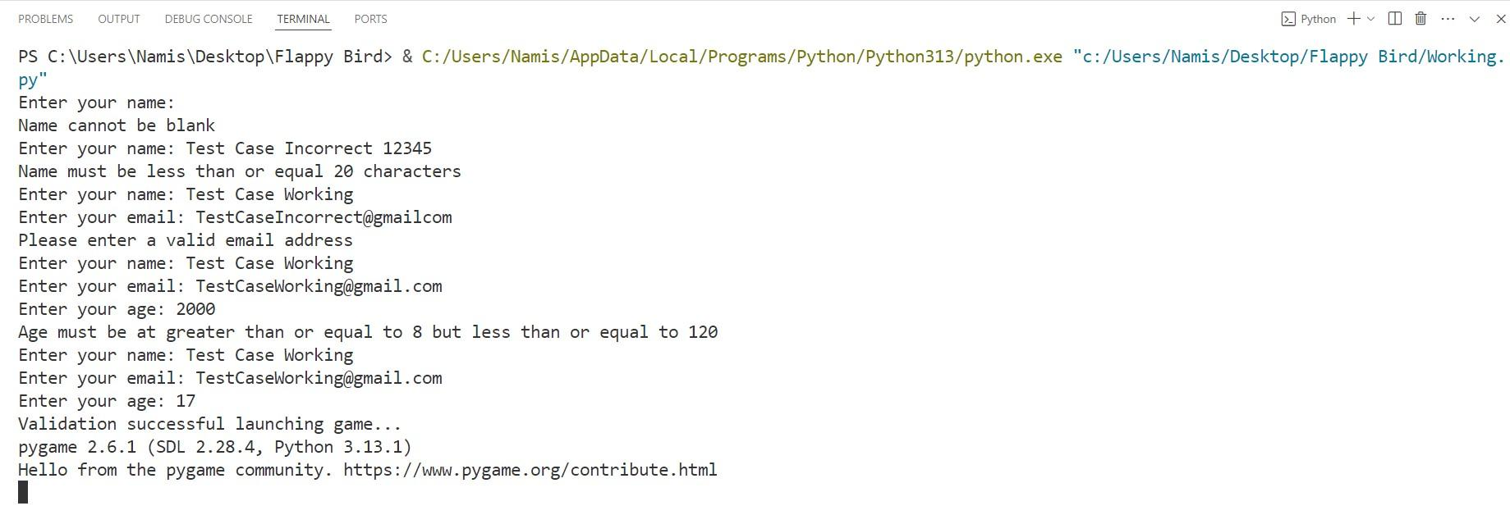
Game Menu Interface
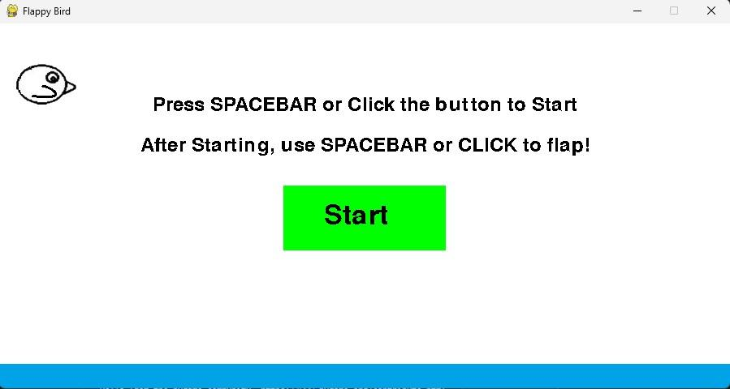
Game Active Interface
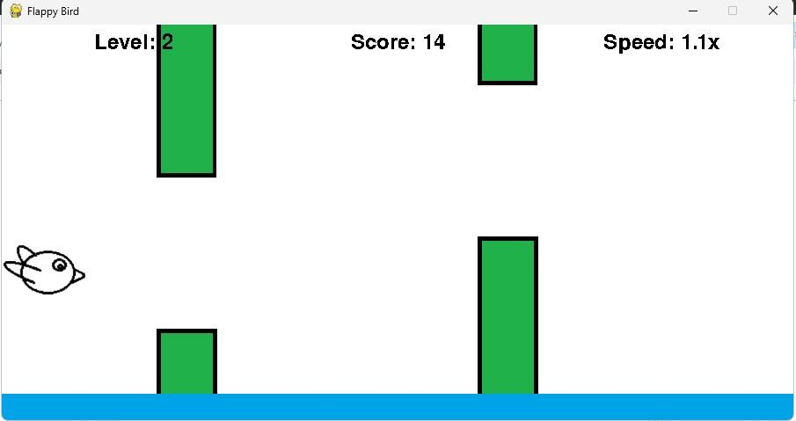
Game Retry Interface
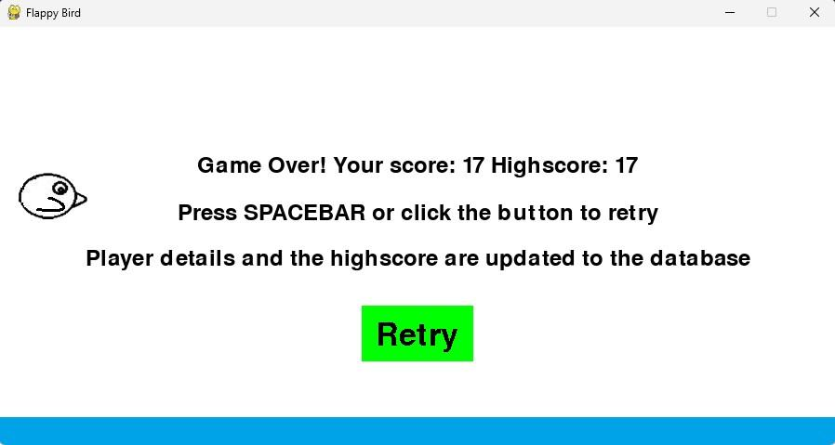

Program Code
#This Function that checks for input validation on name,email and age_input
def input_validation(): ㅤ while True:
ㅤ ㅤ name = input("Enter your name: ") ㅤ ㅤ name.strip() ㅤ ㅤ if len(name)> 20 :
ㅤ ㅤ ㅤ print("Name must be less than or equal 20 characters") ㅤ ㅤ ㅤ ㅤ ㅤ continue
ㅤ ㅤ if name == "": ㅤ ㅤ ㅤ ㅤ ㅤ print("Name cannot be blank") ㅤ ㅤ
ㅤ ㅤ ㅤ continue
ㅤ ㅤ email = input("Enter your email: ") ㅤ ㅤ
ㅤ ㅤ email.strip()
ㅤ ㅤ if "@" not in email or "." not in email.split("@")[-1]: ㅤ ㅤ ㅤ ㅤ ㅤ print("Please enter a valid email address") ㅤ ㅤ
ㅤ ㅤ ㅤ continue ㅤ ㅤ else: ㅤ ㅤ ㅤ parts = email.split(“@”) ㅤ ㅤ ㅤ local_part = parts[0]
ㅤ ㅤ ㅤ domain = parts[1] ㅤ ㅤ ㅤ if “.” not in domain or domain.startswith(“.”) or domain.endswith(“.”): ㅤ ㅤ ㅤ ㅤ print(“Please enter a valid email address”)
ㅤ ㅤ ㅤ ㅤ continue ㅤ ㅤ ㅤ if not local_part or “ ” in local_part:
ㅤ ㅤ ㅤ ㅤ print(“Please enter a valid email address”) ㅤ ㅤ ㅤ ㅤ continue ㅤ ㅤ ㅤ for checkempty in domain.split(“.”): ㅤ ㅤ ㅤ ㅤ if checkempty == “”: ㅤ ㅤ ㅤ ㅤ ㅤ print(“Please enter valid email address”)
ㅤ ㅤ ㅤ ㅤ ㅤ continue ㅤ ㅤ ㅤ ㅤ ㅤ ㅤ age_input = input("Enter your age: ") ㅤ ㅤ ㅤ ㅤ ㅤ ㅤ age_input.strip()
ㅤ ㅤ if not age_input.isdigit(): ㅤ ㅤ
ㅤ ㅤ ㅤ print("Age must be a valid number")
ㅤ ㅤ ㅤ continue
ㅤ ㅤ age = int(age_input) ㅤ ㅤ if age < 8 or age > 120: ㅤ ㅤ ㅤ ㅤ ㅤ print("Age must be at greater than or equal to 8 but less than or equal to 120")
ㅤ ㅤ ㅤ continue print(“Validation successful launching game….”) return name, age,email
#Function that sorts the score def Partial_BubbleSort(scores_array): ㅤ ㅤ
ㅤ swapped = True ㅤ n = len(scores_array) ㅤ while swapped: ㅤ ㅤ
ㅤ ㅤ swapped = Falseㅤ ㅤ ㅤ ㅤ ㅤ ㅤ for i in range(n-1):
ㅤ ㅤ ㅤ if scores_array[i] < scores_array[i+1]: ㅤ ㅤ ㅤ ㅤ ㅤ ㅤ
ㅤ ㅤ ㅤ ㅤ scores_array[i],scores_array[i+1] = scores_array [i+1],scores_array[i] ㅤ ㅤ return scores_array name,age,email = input_validation()
import pygame import mysql.connector
import random from sys import exit #Allows the program to exit properly

#This function establishes a connection to the local database server and creates a
database if it doesn't exist def create_connection(): ㅤ global mydatabase,mycursor ㅤ ㅤ
ㅤ mydatabase = mysql.connector.connect(ㅤ ㅤ ㅤ ㅤ ㅤ ㅤ ㅤ ㅤ ㅤ ㅤ ㅤ ㅤ
ㅤ host="localhost", ㅤ ㅤ ㅤ user="root",ㅤ ㅤ ㅤ ㅤ ㅤ ㅤ ㅤ
ㅤ password=""
ㅤ ) ㅤ ㅤ
ㅤ mycursor = mydatabase.cursor() ㅤ ㅤ ㅤ ㅤ ㅤ ㅤ ㅤ ㅤ ㅤ mycursor.execute("CREATE DATABASE IF NOT EXISTS Playerdatabase")ㅤ ㅤ ㅤ ㅤ mydatabase.database = "Playerdatabase" ㅤ ㅤ ㅤ ㅤ ㅤ ㅤ
ㅤ mycursor.execute(""" ㅤ ㅤ
ㅤ ㅤ CREATE TABLE IF NOT EXISTS playerdetails (ㅤ ㅤ ㅤ ㅤ ㅤ ㅤ ㅤ ㅤ ㅤ ㅤ ㅤ ㅤ player_id INT AUTO_INCREMENT PRIMARY KEY,ㅤ ㅤ ㅤ ㅤ ㅤ ㅤ ㅤ
ㅤ ㅤ ㅤ name VARCHAR(255), ㅤ ㅤ ㅤ email VARCHAR(255), ㅤ ㅤ ㅤ age INT, ㅤ ㅤ
ㅤ ㅤ ㅤ highscore INT, ㅤ ㅤ ㅤ ㅤ level INT,
ㅤ ㅤ ㅤ retries INT ㅤ ㅤ )
""")
create_connection()
#This function Updates or inserts player data everytime the player dies def update_or_inserts_records(name, age, email,highscore,level,retries): ㅤ query = "SELECT player_id,highscore FROM playerdetails WHERE name = %s ㅤ ㅤ AND age = %s AND email = %s" ㅤ ㅤ ㅤ ㅤ ㅤ ㅤ ㅤ ㅤ ㅤ ㅤ ㅤ ㅤ mycursor.execute(query,(name,age,email)) ㅤ result = mycursor.fetchone()
ㅤ if result: ㅤ ㅤ ㅤ ㅤ player_id = result[0] ㅤ ㅤ ㅤ ㅤ ㅤ ㅤ previous_highscore = result[1] ㅤ ㅤ if highscore > previous_highscore: ㅤ ㅤ ㅤ ㅤ
ㅤ ㅤ ㅤ update_query = "UPDATE playerdetails SET highscore = %s,level = ㅤ ㅤ ㅤ ㅤ ㅤ %s,retries = %s WHERE player_id = %s" ㅤ ㅤ ㅤ ㅤ ㅤ ㅤ ㅤ ㅤ ㅤ ㅤ ㅤ ㅤ ㅤ mycursor.execute(update_query,(highscore,level,retries,player_id))
ㅤ else: ㅤ ㅤ
ㅤ ㅤ insert_query = "INSERT INTO ㅤ ㅤ ㅤ ㅤ ㅤ ㅤ ㅤ ㅤ ㅤ ㅤ ㅤ ㅤ ㅤ ㅤ ㅤ ㅤ playerdetails(name,age,email,highscore,level,retries)ㅤ ㅤ ㅤ ㅤ ㅤ ㅤ ㅤ ㅤ ㅤ ㅤ VALUES(%s,%s,%s,%s,%s,%s)"ㅤ ㅤ ㅤ ㅤ ㅤ ㅤ ㅤ ㅤ ㅤ ㅤ ㅤ ㅤ ㅤ ㅤ ㅤ ㅤ mycursor.execute(insert_query,(name,age,email,highscore,level,retries))ㅤ ㅤ ㅤ mydatabase.commit()

"""The Bird class represents the player so it handles the appearance,movement and collision mechanics of the player.The bird or the player character can be controlled
using this class.""" class Bird(pygame.sprite.Sprite):
ㅤ def __init__(self): #Constructor for Bird class ㅤ ㅤ ㅤ ㅤ ㅤ ㅤ super().__init__() ㅤ ㅤ ㅤ ㅤ ㅤ ㅤ self.bird_frame_1 = pygame.image.load('Bird/Bird_frame_1.png').convert_alpha() ㅤ ㅤ self.bird_frame_2 = pygame.image.load('Bird/Bird_frame_2.png').convert_alpha()
ㅤ ㅤ self.image = self.bird_frame_2 ㅤ ㅤ ㅤ ㅤ self.rect = self.image.get_rect(midbottom=(50, 100)) ㅤ ㅤ ㅤ ㅤ self.gravity = 0

ㅤ """This function implements gravity on the bird and checks for collision with the ㅤ
ㅤ ground if a collision is detected true is returned else false""" ㅤ def handleGravityAndCollision(self): ㅤ ㅤ if game_active: ㅤ ㅤ ㅤ ㅤ ㅤ ㅤ ㅤ ㅤ ㅤ self.gravity += 0.35 ㅤ ㅤ ㅤ ㅤ ㅤ self.rect.y += self.gravity ㅤ ㅤ if self.rect.bottom >= 420: ㅤ ㅤ ㅤ ㅤ
ㅤ ㅤ ㅤ self.rect.bottom = 420
ㅤ ㅤ ㅤ return True
ㅤ ㅤ return False
ㅤ def flap(self): #This function contains code to allow the bird to flap
ㅤ ㅤ if game_active: | ㅤ ㅤ
ㅤ ㅤ ㅤ self.gravity = -5.75 | ㅤ ㅤ
ㅤ ㅤ ㅤ self.image = self.bird_frame_1
ㅤ def stop_flap(self): #This function contains code to reset flap image | ㅤ ㅤ
ㅤ ㅤ self.image = self.bird_frame_2
"""Pole class is responsible for npc (non-player controlled) characters which are the poles that the bird has to escape in order to survive.This class is responsible for
movement,collision and appearance""" class Pole(pygame.sprite.Sprite):
ㅤ def __init__(self, x, y, is_top): #Constructor for Pole class ㅤ ㅤ ㅤ ㅤ
ㅤ ㅤsuper().__init__() ㅤ ㅤ
ㅤ ㅤself.image = pygame.image.load('Vertical pole/Pole_Bottom.png').convert_alpha()
ㅤ ㅤ #Sets image for bottom pole
ㅤ if is_top: ㅤ ㅤ
ㅤ ㅤ self.image = pygame.image.load('Vertical pole/Pole_Top.png').convert_alpha()
ㅤ ㅤ self.rect = self.image.get_rect(center=(x, y)) ㅤ ㅤ ㅤ ㅤ self.speed = 5
#This function updates the position of the pole and removes it from the game if it moves off-screen. ㅤ def update(self): ㅤ ㅤ if game_active:
ㅤ ㅤ ㅤ #As the game progresses the speed multiplier and speed is increased ㅤ ㅤ ㅤ ㅤ self.rect.x -= self.speed * speed_multiplier
ㅤ ㅤ if self.rect.right < 0: ㅤ ㅤ
ㅤ ㅤ ㅤ self.kill() #Pole is removed if it goes out of the screen
pygame.init()
screen = pygame.display.set_mode((900, 450)) #900 x 450 resolution pygame.display.set_caption('Flappy Bird') clock = pygame.time.Clock()
water_surf = pygame.image.load('Water/water.png').convert_alpha() #Water image
#The single bird group is used for player character bird = pygame.sprite.GroupSingle() bird.add(Bird())
#This list contains pole objects to spawn infinite instances.Because using a "Group" wouldn't meet project requirements.
obstacle_list = []
scores = [] #The scores array captures the player's score upon death
GAP_SIZE = 600
POLE_X_START = 950
POLE_Y_MIN = 75
POLE_Y_MAX = 300
#Game state
game_active = False #This variable defines the game active state game_over = False #This variable defines the game over state score_reset_time = 0 # Tracks the start time of the score calculation level = 1 #This variable keeps track of player level and updates it retries = 0 #This variable counts the number of retries the player makes speed_multiplier = 1 #This variable keeps track of the pole speed next_level_score = 10 #This variable keeps count of the next score needed to increase
the level and speed_multiplier
score_recorded = False #This variable ensures that score is recorded once sorted = False #This variable ensures score is sorted once highscore = 0 #This variable stores the highscore
#This function creates top and bottom poles with a random gap, adjusts their positions, and adds them to the obstacle list. def create_poles():
ㅤ gap_y = random.randint(POLE_Y_MIN, POLE_Y_MAX) ㅤ ㅤ ㅤ top_pole = Pole(POLE_X_START, gap_y - GAP_SIZE / 2 - 330, True) ㅤ ㅤ ㅤ bottom_pole = Pole(POLE_X_START, gap_y + GAP_SIZE / 2, False) ㅤ ㅤ ㅤ ㅤ ㅤ obstacle_list.append(top_pole) ㅤ ㅤ ㅤ ㅤ ㅤ ㅤ ㅤ ㅤ ㅤ ㅤ obstacle_list.append(bottom_pole)
#This function dynamically updates the scores with intended logic and displays it
def update_and_display_score(): ㅤ ㅤ ㅤ ㅤ
ㅤ """"pygame.ticks gives the time since the game started in ms so the score is reset ㅤ ㅤ using score_reset_time,set when the game starts""" ㅤ score = int(pygame.time.get_ticks() / 1000) - score_reset_time ㅤ ㅤ ㅤ score_surf = font.render(f'Score: {score}', False, 'Black') ㅤ ㅤ ㅤ score_rect = score_surf.get_rect(center=(450, 20)) ㅤ ㅤ ㅤ ㅤ ㅤ ㅤ
ㅤ screen.blit(score_surf, score_rect) ㅤ return score
#This function displays the level and speed_multplier during the game
def display_level_and_speed(): ㅤ ㅤ ㅤ ㅤ
ㅤ level_surf = font.render(f'Level: {level}', False, 'Black') ㅤ ㅤ ㅤ level_rect = level_surf.get_rect(center=(150, 20)) ㅤ ㅤ ㅤ ㅤ ㅤ ㅤ
ㅤ screen.blit(level_surf, level_rect) ㅤ ㅤ ㅤ speed_surf = font.render(f'Speed: {speed_multiplier:.1f}x', False, 'Black') ㅤ ㅤ ㅤ speed_rect = speed_surf.get_rect(center=(750, 20))screen.blit(speed_surf, ㅤ ㅤ ㅤ speed_rect)
font_large = pygame.font.Font(None, 50) font = pygame.font.Font(None, 35)
# Creation of the start button
start_button_rect = pygame.Rect(350, 200, 200, 80)
button_text = font_large.render("Start", False, (0, 0, 0))
# Creation of the retry button
retry_button_rect = pygame.Rect(390,300, 120, 60)
button2_text = font_large.render("Retry", False, (0, 0, 0))
# Main loop
while True: ㅤ ㅤ ㅤ ㅤ ㅤ screen.fill('White') ㅤ ㅤ ㅤ ㅤ ㅤ bird.draw(screen) ㅤ for event in pygame.event.get(): #loops through all events in pygame
ㅤ ㅤ if event.type == pygame.QUIT: ㅤ ㅤ ㅤ ㅤ
ㅤ ㅤ ㅤ pygame.quit() ㅤ ㅤ ㅤ exit() ㅤ ㅤ if not game_active and not game_over: ㅤ ㅤ ㅤ if event.type == pygame.MOUSEBUTTONDOWN:
ㅤ ㅤ ㅤ ㅤ if start_button_rect.collidepoint(event.pos): ㅤ ㅤ ㅤ ㅤ ㅤ ㅤ ㅤ game_active = True ㅤ ㅤ ㅤ ㅤ
ㅤ ㅤ ㅤ ㅤ ㅤ #score_reset_time resets the score at the start of the game ㅤ ㅤ ㅤ ㅤ ㅤ ㅤ ㅤ score_reset_time = int(pygame.time.get_ticks() / 1000) ㅤ ㅤ ㅤ ㅤ ㅤ #The timer below is for the pole obstacle which is defined later ㅤ ㅤ ㅤ ㅤ ㅤ ㅤ ㅤ #changing 1200 below will change the poles spawn rate 1200 is in ms ㅤ ㅤ ㅤ ㅤ ㅤ pygame.time.set_timer(pygame.USEREVENT + 1, 1200) ㅤ ㅤ ㅤ if event.type == pygame.KEYDOWN:
ㅤ ㅤ ㅤ ㅤ if event.key == pygame.K_SPACE: ㅤ ㅤ
ㅤ ㅤ ㅤ ㅤ ㅤ game_active = True ㅤ ㅤ ㅤ ㅤ ㅤ # Start the score timer ㅤ ㅤ ㅤ ㅤ ㅤ ㅤ ㅤ ㅤ ㅤ ㅤ ㅤ ㅤ ㅤ
ㅤ ㅤ ㅤ ㅤ ㅤ score_reset_time = int(pygame.time.get_ticks() / 1000) ㅤ ㅤ ㅤ ㅤ ㅤ pygame.time.set_timer(pygame.USEREVENT + 1, 1200)
ㅤ ㅤ #The bird can be flapped by either spacebar or mousebutton press ㅤ ㅤ if game_active and event.type == pygame.KEYDOWN: ㅤ ㅤ ㅤ if event.key == pygame.K_SPACE: ㅤ ㅤ ㅤ ㅤ ㅤ ㅤ ㅤ ㅤ bird.sprite.flap()
if game_active and event.type == pygame.KEYUP:
ㅤ if event.key == pygame.K_SPACE: ㅤ ㅤ ㅤ ㅤ ㅤ ㅤ ㅤ ㅤ ㅤ ㅤ bird.sprite.stop_flap( )
ㅤ ㅤ if game_active and event.type == pygame.MOUSEBUTTONDOWN: ㅤ ㅤ
ㅤ ㅤ ㅤ bird.sprite.flap()
ㅤ ㅤ if game_active and event.type == pygame.MOUSEBUTTONUP:ㅤ ㅤ ㅤ ㅤ ㅤ ㅤ ㅤ ㅤ bird.sprite.stop_flap()
ㅤ ㅤ if game_over:
ㅤ ㅤ ㅤ if event.type == pygame.MOUSEBUTTONDOWN:
ㅤ ㅤ ㅤ ㅤ if retry_button_rect.collidepoint(event.pos): | ㅤ ㅤ
ㅤ ㅤ ㅤ ㅤ ㅤ game_active = True | ㅤ ㅤ
ㅤ ㅤ ㅤ ㅤ ㅤ game_over = False | ㅤ ㅤ ㅤ ㅤ ㅤ ㅤ
ㅤ ㅤ ㅤ ㅤ ㅤ bird.sprite.rect.midbottom = (50, 100) | ㅤ ㅤ ㅤ ㅤ
ㅤ ㅤ ㅤ ㅤ ㅤ bird.sprite.gravity = 0
ㅤ ㅤ ㅤ ㅤ ㅤ score_recorded = False | ㅤ ㅤ ㅤ ㅤ
ㅤ ㅤ ㅤ ㅤ ㅤ obstacle_list.clear() | ㅤ ㅤ
ㅤ ㅤ ㅤ #Score time is reset for the next instance of score to be recorded accurately ㅤ ㅤ ㅤ ㅤ ㅤ score_reset_time = int(pygame.time.get_ticks() / 1000) ㅤ ㅤ ㅤ ㅤ ㅤ ㅤ ㅤ ㅤ ㅤ pygame.time.set_timer(pygame.USEREVENT + 1, 1200)
ㅤ ㅤ ㅤ ㅤ ㅤ level = 1 ㅤ ㅤ ㅤ ㅤ ㅤ ㅤ ㅤ ㅤ ㅤ speed_multiplier = 1 ㅤ ㅤ ㅤ ㅤ ㅤ retries += 1
ㅤ ㅤ ㅤ ㅤ ㅤ #Next level score is reset to update speed and level accurately ㅤ ㅤ ㅤ ㅤ ㅤ ㅤ ㅤ next_level_score = 10
ㅤ ㅤ ㅤ if event.type == pygame.KEYDOWN: ㅤ ㅤ ㅤ ㅤ if event.key == pygame.K_SPACE: ㅤ ㅤ ㅤ ㅤ ㅤ ㅤ ㅤ game_active = True ㅤ ㅤ ㅤ ㅤ ㅤ ㅤ ㅤ game_over = False ㅤ ㅤ ㅤ ㅤ ㅤ ㅤ ㅤ ㅤ ㅤ ㅤ ㅤ bird.sprite.rect.midbottom = (50, 100) ㅤ ㅤ ㅤ ㅤ ㅤ ㅤ ㅤ ㅤ ㅤ bird.sprite.gravity = 0 ㅤ ㅤ ㅤ ㅤ ㅤ ㅤ ㅤ ㅤ ㅤ score_recorded = False ㅤ ㅤ ㅤ ㅤ ㅤ ㅤ ㅤ ㅤ ㅤ obstacle_list.clear() ㅤ ㅤ ㅤ ㅤ
ㅤ ㅤ ㅤ ㅤ ㅤ score_reset_time = int(pygame.time.get_ticks() / 1000) ㅤ ㅤ ㅤ ㅤ ㅤ ㅤ ㅤ ㅤ ㅤ pygame.time.set_timer(pygame.USEREVENT + 1, 1200) ㅤ ㅤ ㅤ ㅤ ㅤ retries += 1
ㅤ ㅤ ㅤ ㅤ ㅤ level = 1 ㅤ ㅤ ㅤ ㅤ ㅤ ㅤ ㅤ ㅤ ㅤ ㅤ ㅤ ㅤ ㅤ
ㅤ ㅤ ㅤ speed_multiplier = 1  ㅤ ㅤ ㅤ next_level_score = 10 | ㅤ ㅤ ㅤ ㅤ
ㅤ ㅤ if game_active and event.type == pygame.USEREVENT + 1: ㅤ ㅤ ㅤ create_poles() #To add poles when the game is active | ㅤ ㅤ ㅤ ㅤ
ㅤ if not game_active and not game_over: #Display for game menu | ㅤ ㅤ ㅤ ㅤ
ㅤ ㅤ pygame.draw.rect(screen,(0,255,0), start_button_rect) ㅤ ㅤ ㅤ ㅤ ㅤ ㅤ ㅤ ㅤ screen.blit(button_text, (start_button_rect.x + 50, start_button_rect.y + 20)) ㅤ ㅤ start_text = font.render("Press SPACEBAR or Click the button to Start",False-
-,'Black') ㅤ ㅤ
ㅤ ㅤ start_rect = start_text.get_rect(center=(450, 150)) ㅤ ㅤ ㅤ ㅤ ㅤ ㅤ ㅤ ㅤ screen.blit(start_text, start_rect)
ㅤ if game_active:
ㅤ ㅤ “““The for loop updates each pole, draws it on screen, and ends the game if ㅤ
ㅤ ㅤ ㅤ collision with the bird occurs.””” ㅤ ㅤ for pole in obstacle_list: ㅤ ㅤ ㅤ ㅤ ㅤ pole.update() ㅤ ㅤ ㅤ ㅤ ㅤ ㅤ ㅤ ㅤ ㅤ screen.blit(pole.image, pole.rect)
ㅤ ㅤ ㅤ if pygame.sprite.collide_rect(bird.sprite, pole): #Collision Mechanics
ㅤ ㅤ ㅤ ㅤ game_active = False ㅤ ㅤ ㅤ ㅤ ㅤ ㅤ game_over = True ㅤ ㅤ ㅤ ㅤ break ㅤ ㅤ score = update_and_display_score()
ㅤ ㅤ if score >= next_level_score: ㅤ ㅤ ㅤ level += 1 ㅤ ㅤ ㅤ ㅤ ㅤ ㅤ ㅤ next_level_score += 10 ㅤ ㅤ ㅤ ㅤ ㅤ ㅤ ㅤ if speed_multiplier < 2 : speed_multilpier += 0.1
ㅤ ㅤ display_level_and_speed()
#handleGravityAndCollision method takes care of bird gravity and returns true if
ㅤ ㅤ the bird collides with the ground ㅤ ㅤ if bird.sprite.handleGravityAndCollision():
ㅤ ㅤ ㅤ game_active = False ㅤ ㅤ ㅤ ㅤ ㅤ game_over = True
ㅤ if game_over: ㅤ ㅤ
ㅤ ㅤ #score should be recorded only once and to do that score_recorded exists
if not score_recorded: ㅤ ㅤ ㅤ ㅤ ㅤ ㅤ ㅤ scores.append(score) ㅤ ㅤ ㅤ ㅤ
ㅤ ㅤ ㅤ score_recorded = True
ㅤ ㅤ #score should be sorted only once and to do that score_recorded exists ㅤ ㅤ if not sorted : ㅤ ㅤ ㅤ scores = Partial_BubbleSort(scores)
ㅤ ㅤ if scores: ㅤ ㅤ ㅤ ㅤ ㅤ highscore = scores[0]
ㅤ ㅤ #Next few lines of code is focused on the UI of the game ㅤ ㅤ ㅤ ㅤ ㅤ ㅤ ㅤ ㅤ pygame.draw.rect(screen, (0, 255, 0), retry_button_rect) ㅤ ㅤ ㅤ ㅤ ㅤㅤ ㅤ ㅤ screen.blit(button2_text, (retry_button_rect.x + 15, retry_button_rect.y + 15)) ㅤ ㅤ game_over_text = font.render("Game Over! Your score: ” + str(score) + ㅤ ㅤ
“Highscore: " + str(highscore)- -,True, 'Black') ㅤ ㅤ ㅤ ㅤ game_over_rect = game_over_text.get_rect(center=(450, 150)) ㅤ ㅤ ㅤ ㅤ ㅤ ㅤ screen.blit(game_over_text, game_over_rect) ㅤ ㅤ ㅤ ㅤ
ㅤ ㅤ retry_info_text = font.render("Press SPACEBAR or click the button to retry",True,
'Black') ㅤ ㅤ ㅤ ㅤ ㅤ ㅤ retry_info_rect = retry_info_text.get_rect(center=(450, 200)) ㅤ ㅤ ㅤ ㅤ ㅤ ㅤ ㅤ ㅤ screen.blit(retry_info_text, retry_info_rect)
ㅤ ㅤ “““The method below updates the records in the database or inserts the data like ㅤ ㅤ highscore,level and retries”””” ㅤ ㅤ ㅤ ㅤ ㅤ ㅤ ㅤ ㅤ ㅤ ㅤ ㅤ update_or_inserts_records(name, age, email,highscore,level,retries)
ㅤ ㅤ #The next few lines of code is focused on UI again ㅤ ㅤ ㅤ ㅤ ㅤ ㅤ ㅤ ㅤ database_updation_text = font.render("Player details and the highscore are
updated to the database", True, 'Black') ㅤ ㅤ ㅤ ㅤ ㅤ ㅤ
ㅤ ㅤ database_updation_rect = database_updation_text.get_rect(center=(450, 250)) ㅤ ㅤ screen.blit(database_updation_text,database_updation_rect)
ㅤ screen.blit(water_surf, (0, 420)) #water image ㅤ ㅤ ㅤ ㅤ ㅤ ㅤ
ㅤ pygame.display.update() ㅤ clock.tick(60)

SQL Code
The Queries mentioned are implemented in the program code above
Query 1:
CREATE DATABASE IF NOT EXISTS Playerdatabase
Query 2:
CREATE TABLE IF NOT EXISTS playerdetails (
ㅤ id INT AUTO_INCREMENT PRIMARY KEY,
ㅤ name VARCHAR(255), ㅤ age INT, ㅤ email VARCHAR(255), ㅤ highscore INT, ㅤ level INT,
ㅤ retries INT
)
Query 3:
SELECT player_id,highscore
FROM playerdetails WHERE name = {name input} AND age = {age input} AND email = {email input} Query 4a:
UPDATE playerdetails
SET highscore = {highscore variable}, level = {level variable}, retries = {retries variable} WHERE player_id = {player_id variable} #player_id is the player id of the above query
Query 4b:
INSERT INTO playerdetails(name,age,email,highscore,level,retries)
VALUES ({name input}, {age input}, {email input}, {highscore variable}, {level variable}, {retries variable})

Screenshots of Database
Before Starting game (during input validation) Database is created but no tables exists

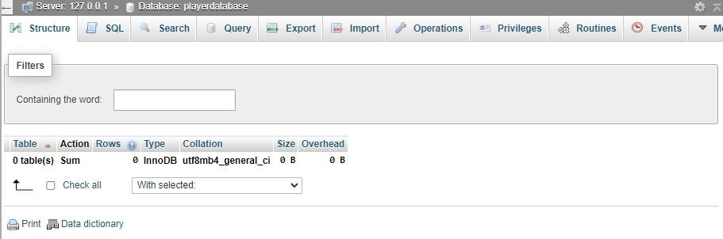
After Input Validation a table is created, Records are updated/inserted when the player dies. ㅤ ㅤ
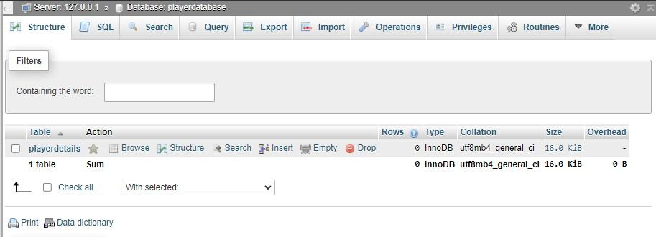
If the game is closed directly without recording any scores there is no data because all fields are required to register a record.
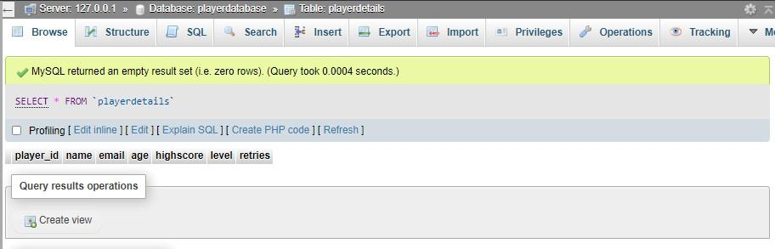
Record data is shown below with all data registered
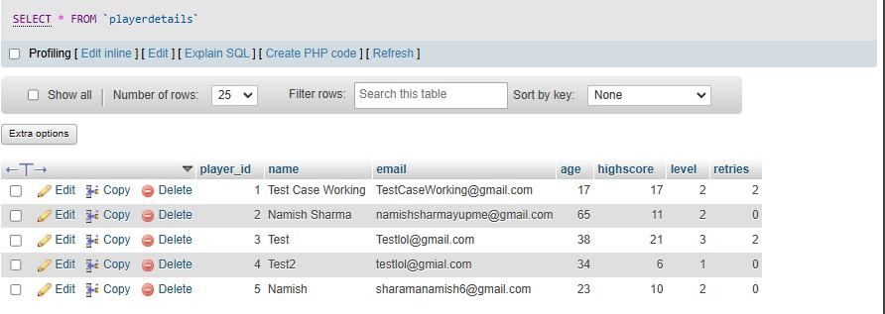

Research and development of new skills and knowledge
To create my flappy bird game I researched skills and implemented it in the game.These skills included
- Learning a whole new library, Pygame which is an open source library for writing video games. I learnt a lot of details about video games in the process of the backend, frontend and overall game design. Most of the in-game mechanisms like interaction with the ground,enemies in general were done using rectangles rather than storing each matching pixels as a separate entity. Rectangles are placed on images which makes it easier to detect collisions, switch images and also interact with surfaces i.e. water.
- Learning movement mechanisms is also a core skill in a particular game, for example when jumping the player character the keyboard/mouse inputs are taken . I understood how games are rendered in real time which was a fascinating concept which includes rendering multiple images and working accordingly with keyboard or mouse input. I learnt to use various built in modules of pygame such as creating a timer, creating buttons and score recorder mechanism.
- I learnt how to create an UI in pygame for my game as shown in the screenshots. Various concepts such as 2d plane coordinates and basic shape properties such as colour, anti aliasing and size can be modified using pygame itself. I learnt quite a few image handling methods such as rotozoom and size. Pygame also involves displaying text in any downloadable font and modifying its attributes such as text colour and size etc.
- Learning pygame allowed me to have more practical experience with object oriented programming and develop on my core essentials. I watched this youtube tutorial “Ultimate introduction to pygame” which was a good starter for the core essentials. The website I then was pygame.org and w3schools to elaborate on the basic concepts.
- The functional requirements that required the new skills is listed below :
1.The game must allow the bird to fall naturally due to gravity unless the player presses
the mouse button or the spacebar to make it ascend.
2.Display the bird, poles, and ground.
3.Animate the bird's flapping by switching images when flapping and flying.
4.The game will provide a start and game-over screen.
5.The game must generate poles with a fixed gap at regular intervals.
6.The game must display the end game screen after collision is detected and interactive
buttons such as “Start” and “Retry”.
7.The game must detect user inputs like spacebar, collisions and button press 8. The game asks for player’s details such as player name,email,age. The game
records high scores,retries and level for each individual player.
10.The current score will be displayed during the gameplay, along with the level and speed of the obstacles thus allowing players to track their progress.
11.The game tracks the user's score everytime the user dies the score is stored in the scores array.
13.The game will allow players to retry when they collide with the vertical poles or touch
the ground in-game.
14.As the game progresses the speed of the vertical poles is increased
15.The game must display a start screen with a play button.

Log of ongoing testing

Functional  Requirement(s) being tested | Describe any issues encountered | Resolution of issue | Any references  used (if required)
2.Display the bird, poles, and ground. | The images were not clear and blurry when movement occurred . | Convert alpha which changes the pixels of an image to include the alpha slot in the rgb colour values | https://www.pyg ame.org/docs/re f/surface.html#p ygame.Surface. convert_alpha
9.The game will validate inputs which are the | The player email validation wasn’t rigid enough. | I had to check for a lot of test cases such as inputting no domain or local name. This system

player name,email and their age. |  | is currently quite rigid. I haven't  found a drawback and it's fully tested.
1.The game must allow the bird to fall naturally due to gravity unless the player presses the mouse button or the spacebar to make it ascend. | The bird had an option to skip all poles by flying higher than the poles.  The gravity was also inconsistent as it slowed the bird down at a constant speed rather than accelerating downwards. | The issue was resolved by making the top pole bigger than the bottom pole  The issue was fixed by increasing gravity at lower increments to give a proper acceleration. | https://www.pyg ame.org/docs/re f/image.html
18.A query is created to update the highscores of the player if his current highscore is greater than his previous highscore | Duplicate records were created when player had same name in the database | To resolve this issue I had to introduce two more functional requirements 18 and 19 which updates or adds the records depending whether the player existed | https://www.w3s chools.com/pyth on/python_mys ql_getstarted.as  p
13.The game will allow players to retry when they collide with the vertical poles or touch the ground in-game. | Retry did not remove the variable values for current score, speed multiplier, and level | everything had to be reset after the retry button was pressed.
3.Animate the bird's flapping and falling. | The “rectangles” for each bird were not the same.  Therefore incorrect collisions were registered. | Since pygame draws the rectangle of a class. I had to manually make the image aligned by keeping the same | https://www.pyg ame.org/docs/re f/rect.html
 |  | size for both birds but ensuring consistency when looped.
14.As the game progresses, the speed of the vertical poles shall increase up to a predefined maximum speed limit. | There was no cap on the speed for poles. So it would have become  unplayable after a certain duration. | A cap at 2x is added so the game won't progress any further from the cap.
7.The game constantly checks for collisions between player and the vertical poles during the game to display the game-over phase. | After game-over phase was initiated and retry button was pressed the  bird still kept colliding with the poles causing the  game to end  always | The timer for poles and the bird location was reset therefore a new game loaded. | https://www.pyg ame.org/docs/re f/time.html

Testing of the Problem
Comprehensive test plan
Test  Number | End-user/Functional Requirements to be tested | How it will be tested (including values if required) | Expected Results
Test 1 | 1.The game must allow the bird to fall naturally due to gravity unless the player presses the mouse button or the spacebar to make it ascend. | The game is launched and the bird's gravity is taken into consideration and tested to check if the bird falls at a constant rate. | The bird must accelerate downwards at a constant rate.

Test 2 | 2.Display the bird, poles, and ground(water). | Launch the game and check if all elements appear correctly on the screen. | The bird, poles, and ground should be visible without graphical glitches. The elements must also appear correctly in their correct position
Test 3 | 3.Animate the bird's flapping and falling. | Check the image switches by pressing spacebar or using mouse button | The images should be properly synchronized and depict a "flying bird,". It must function smoothly without any graphical glitches.
Test 4 | 4.The game will provide a main menu and a game-over screen. | Launch the game and  check for both the game menu and death screen. | The game menu phase must be invoked first. The death screen must be displayed when the bird collides with the ground(water) or the poles.
Test 5 | 5.The game must generate poles with a fixed gap at regular intervals. | The pole generation must be verified for consistency, and the timer should function correctly for accurate testing. | The distance between poles must remain consistent, ensuring they are generated with the same gap while appearing at different positions.
Test 6 | 6.After a collision is detected the game must show the death screen with the “Retry” button. | Launch the game and check for the death screen after colliding  with a pole. | The death screen must show the scores, highscore and must contain a retry button.
Test 7 | 7.The game constantly checks for collisions between player and the vertical poles during the | Check for the death register when the bird hits the pole or touches the ground or flies high enough and | The game must  transition to the end game screen when the player touches the ground(water) or vertical

 | game to display the game-over phase. | hits the pole. | poles.
Test 8 | 8. The game asks for player’s details such as player name,email,age. The game records high scores,retries and level for each individual player. | Launch the game to check for inputs such as player  name,email,age. The database is visited to check for accurate data capture for  player details such as scores, level etc. | The game must display text boxes and instructions, such as a prompt to enter the player's name. The database must also have valid player details recorded.
Test 9 | 9.The game will validate keyboard inputs, which are the player's name, email, and age. | Test data is entered to check validation for each field. Show an example for accurate and incorrect test cases. Blank fields, invalid names, are tested for accurate data capture. | The game must accept valid data entries while rejecting invalid inputs with an appropriate error message.
Test 10 | 10.The current score will be displayed during the gameplay, along with the level and speed of the obstacles thus allowing players to track their progress. | Check for UI elements in the game active phase showing the progressive stats of the player and the impact of the stats on the bird. | The UI must show the score, high score, and speed multiplier during the game and ensure they update dynamically, remain visible without obstructing gameplay, and accurately reflect real-time changes in player progress.
Test 11 | 11.The game must track the user's score, and | The scores array is tracked by printing the value of score | The score must be added to the list, when the player dies. The

 | upon the player's death, store the score in the scores array. | during the game(in the game-active phase). The values during the game are compared with the expected values. | sorting algorithm is halted for now so the output will not have an sorted scores array.
Test 12 | 12.The game will implement a “partial” bubble sort algorithm on the scores array and the highest score is displayed using the  “partially” sorted score’s array.(Partial bubblesort explained later in evaluation). | The scores array is tracked by printing the value of score during the game(in the game-active phase). The values during the game are compared with the expected values. The highscore is shown after the game ends. | The sorting algorithm is run alongside and the scores array will be sorted.
Test 13 | 13.The game will allow players to retry when they collide with the vertical poles or touch the ground in-game. | Retry button is tested and the game state is reverted back to the game-active phase. | The retry button must reset all current session data values and load a brand new game with the default spawn locations.
Test 14 | 14.As the game progresses, the speed of the vertical poles shall increase up to a predefined maximum speed limit. | The speed multiplier is checked for its functionality and impact on the bird. | The speed multiplier must increase to 2 for the first 10 levels and then levels off.
Test 15 | 15.The game must display the game menu | Launch the game and check for the game | The game menu must have instructions on how to control the bird

 | with instructions and with the “Start” button. | menu and buttons. | and must contain a “Start” button.
Test 16 | 16. Connection to a database is achieved and a Player database is created. | The game shall automatically create a database upon execution.The  database is hosted locally on your pc therefore the connection with the database is checked. | The database must have a player details table which contains no records. This shows that the connection with your program and database is established.
Test 17 | 17.A query is created to generate the playerdetails table. | The game shall automatically create a database upon execution. | The table must have no records upon execution.
Test 18 | 18.A SELECT query is created to find matching records of an existing player to modify his details for update query | The current player plays another game using the “retry” button. | The record of the player must be updated after the player dies proving the SELECT query returned a result and the details of the player must be updated. If the  SELECT query does not return a result the player data is inserted.
Test 19 | 19.A UPDATE query is created to update the highscores of the player if his current highscore is greater than his previous highscore | The player plays another game with a highscore greater than the previous highscore and then the database record is then checked. | The player must have his highscore,level and retry updated which proves that the update query is executed.

Test 20 | 20.A INSERT query is created to insert the player details if player records do not exist. | A new game session is loaded and the game is played. When the player dies for the first time his records are inserted in the table. | The playerdetails table must contain a new record of the player details who played the new game session.
End-User requirements Testing
Test 21 | 1.Inputs that are taken must have input validation, should provide clear instructions, and display error messages for empty or incorrect fields | The input validation is checked again with different test values for different error messages. | The instructions for the inputs must be detailed. There must be clear feedback on errors when the player enters an invalid input.
Test 22 | 2.The user-interface must be clear enough to understand the controls and mechanics without needing detailed instructions. | Comment on the  usability of the user interface and ease of use for the end user. | The user interface must be clear enough to understand the game mechanics without needing detailed instructions.
Test 23 | 3.The game should become progressively challenging over time. | The obstacle speed increases, and the game provides feedback on the difficulty. | The speed multiplier will increase to 2x if the player doesn't die and stays constant.
Test 24 | 4.Players should be able to see their current score and high score, | The score must be displayed when the player plays the game and both the | The game sends the scores to the database for each individual who runs a new game
 | allowing them to track their progress and set goals for improvement. | score and highscore must be displayed after death. | session so the highscore for each player can also be viewed and future goals can be set.
Test 25 | 5.Players should have the option to start the game when required. | The Start button is tested to check if the player can start the game at will. | This is an essential end-user requirement because it allows the player to initiate the game. Without it, the user may not have control over when the game begins.

Persona and test cases
 | Characteristics of Persona | Test case(s) for this persona
Persona | Bill is 13 years old and has never the iconic flappy bird game, but he has played other runner games such as the offline dino game in chrome. His friend challenges him to the game and they play different game sessions in the same PC. Since the data is recorded in the database, The overall statistics of the player is accessed using the database. | 1.Launch the game.  2.Check if Bill has trouble in the input validation phase to input his data.  3.Check if Bill can read the instructions and error messages precisely and provide accurate data input.  4.Check if Bill can recognize the game menu screen, read the instructions and start playing the game.  5.Observe if Bill understands the game mechanics such as controlling the bird and avoiding the poles.  6.Check if Bill can recognize the game-over screen and restart the game.  7.Check if Bill can navigate to the database and compare his score with his friends who play different
 |  | game sessions with him.

Evidence of requirement testing
Test  Number | Testing evidence
Test 1 | Gravity implementation  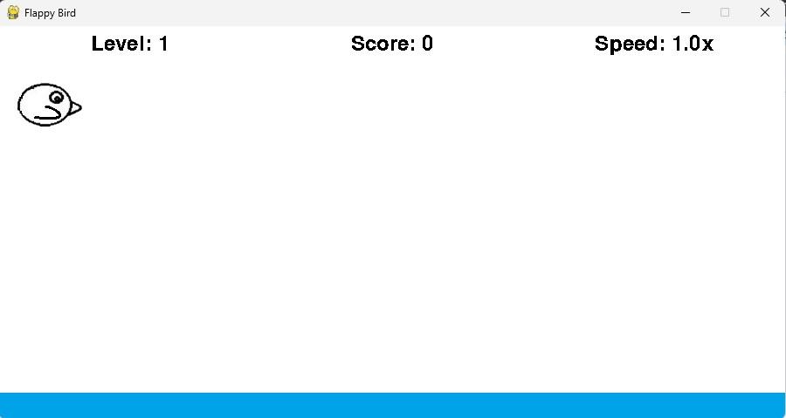  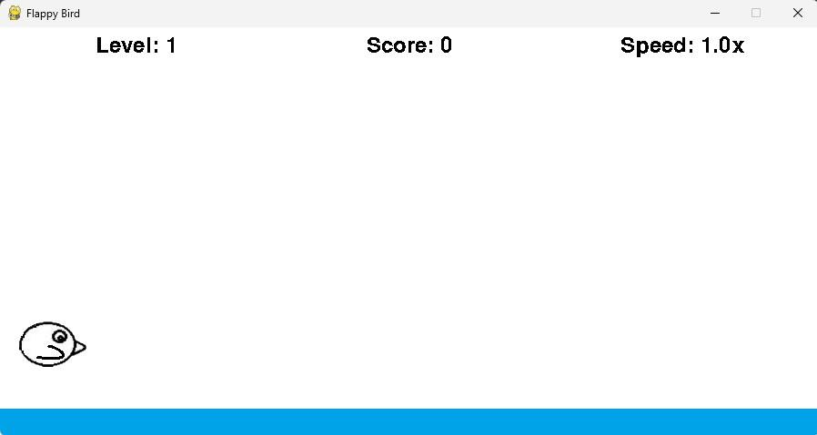
Test 2 | The bird, poles, and ground should be fully rendered, in their correct positions, and without overlapping or missing textures.

 | 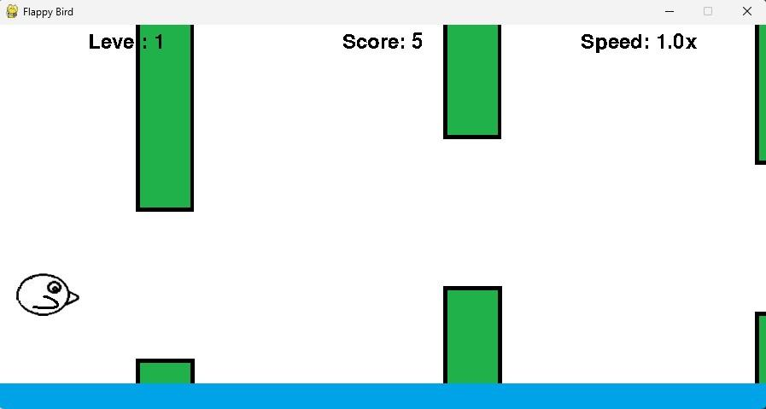
Test 3 | Before clicking the spacebar.    After clicking the spacebar.

 | 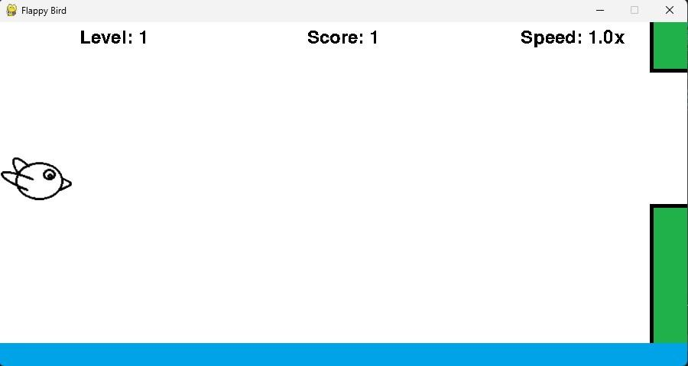
Test 4 | Start screen  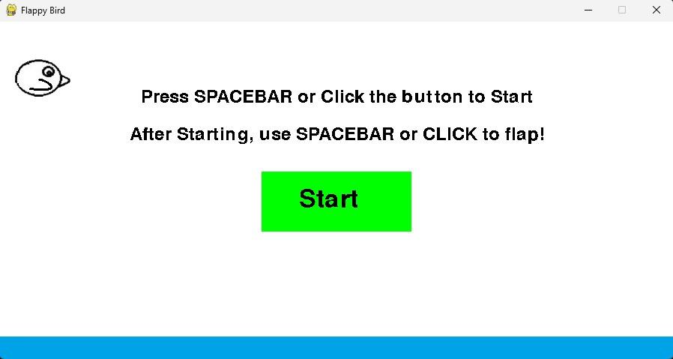  Death screen

 | 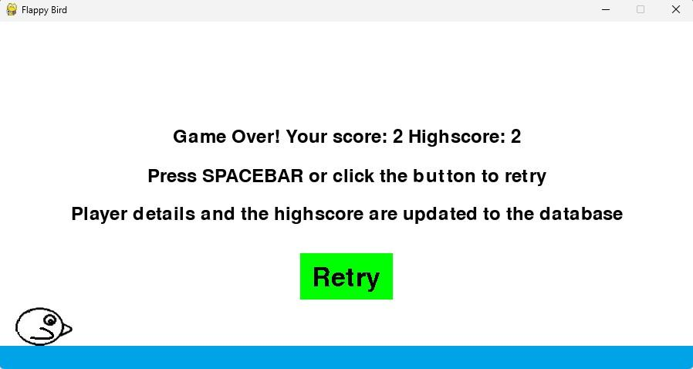
Test 5 | Pole generation evidence  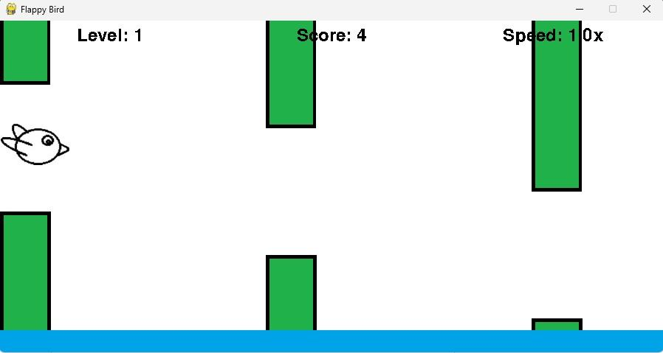
Test 6 | The image shows the UI elements such as highscore, score and retry button shown correctly in the death screen.

 | 
Test 7 | Game active phase (Collision not detected)    Game-over Phase(Ground collision detected)

 | 
Test 8 | Player input phase  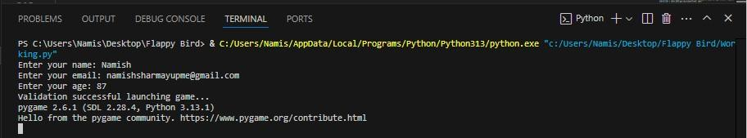  Database datacheck  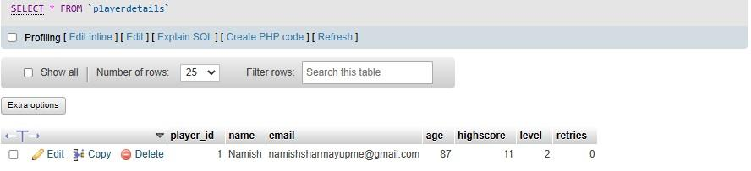
Test 9 | Correct test data example input  Name : Namish  Email : namishsharmayupme@gmail.com Age : 87    Incorrect test data example input
Test 10 | The image contains the visual elements such as score and score_multiplier in the game active phase.

 | 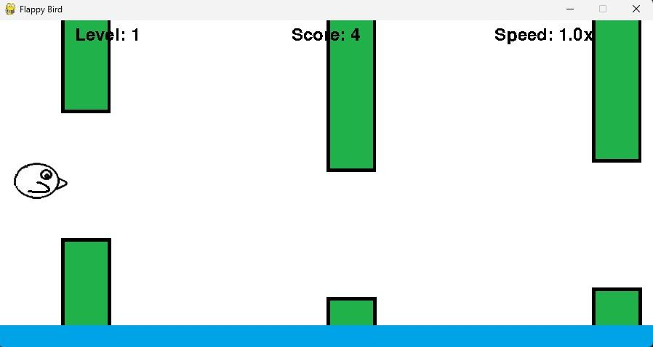
Test 11 | The values of the score array is shown in the screenshot below. Initially the array was empty, but when the player died the array was updated.  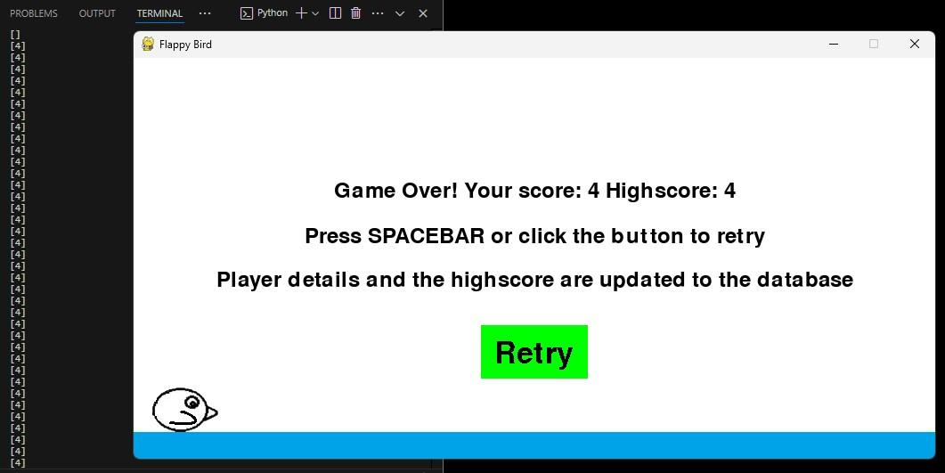
Test 12 | The pictures below show a test run of the game while inspecting the scores array. In the first picture, the scores array contains [17, 9, 7, 5]. In the second picture, the array is updated to [31, 17, 9, 7, 5] after the player's death. The high score is also displayed on the screen after sorting and retrieving the highest value.

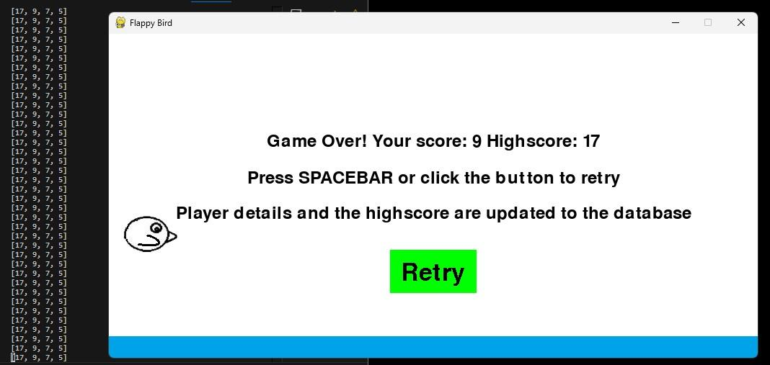
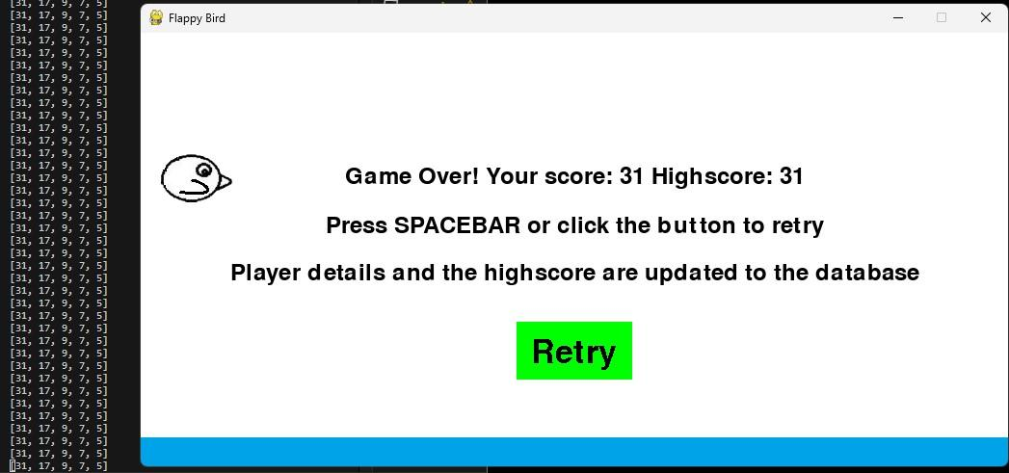
Test 13 | Before clicking retry button  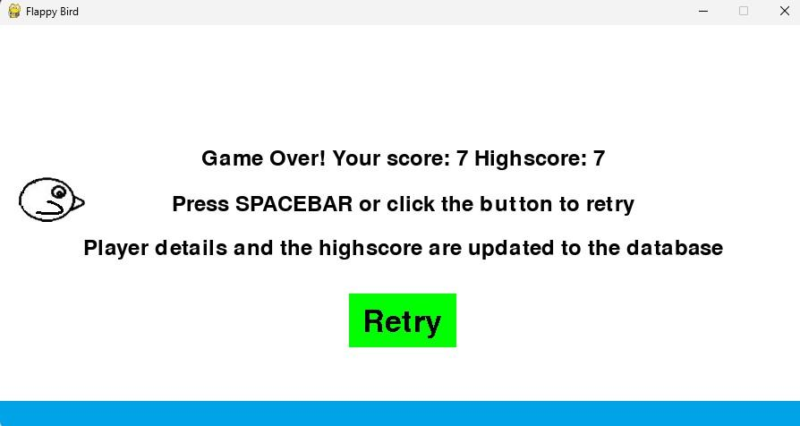  After clicking retry button (game successfully rebooted)

 | 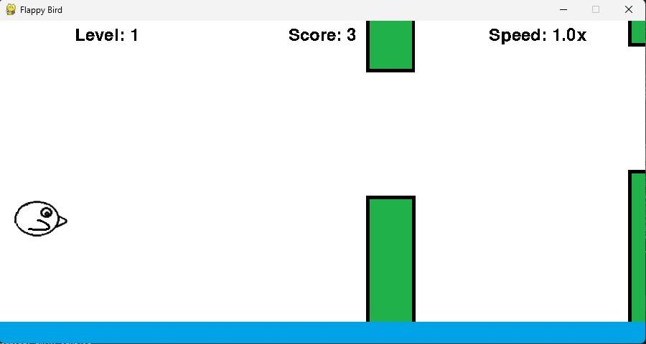
Test 14 | The bird's speed does not actually increase with the speed multiplier. Instead, the poles move faster, creating the illusion that the bird is flying forward. Throughout the game, the bird remains in the same position, only flapping its wings while the poles move past it.  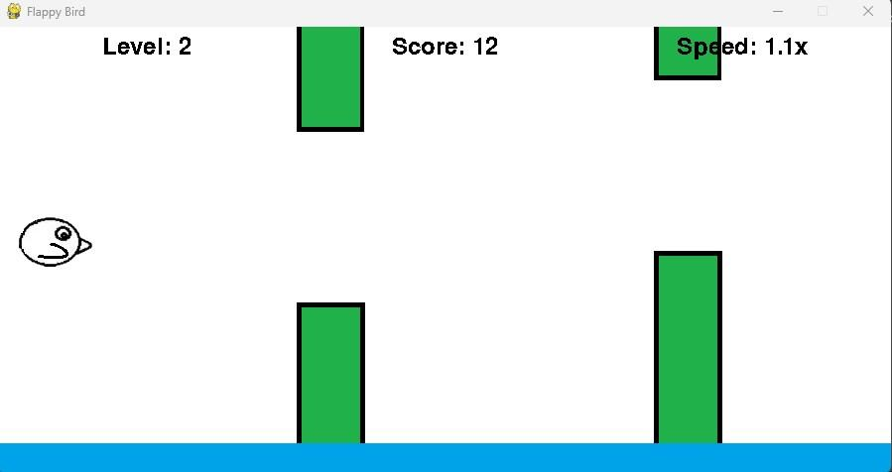
Test 15 | The game menu shows the start button and instructions needed for a beginner to understand the layout of the game.

 | 
Test 16 | The screenshot below shows the Player database created after program execution.  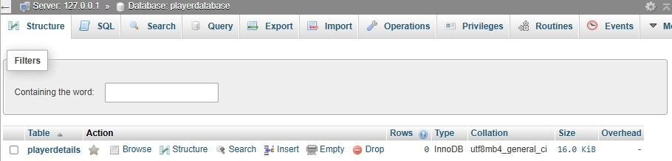
Test 17 | The screenshot below shows the playerdetails database which is created after program execution.  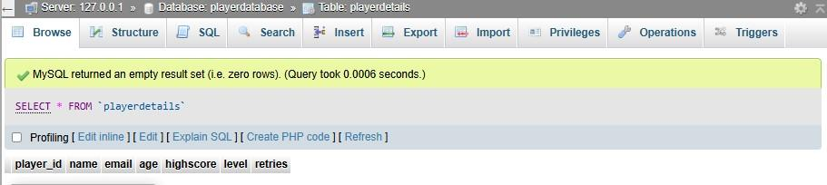
Test 18 | A game is played, the player's details are inserted into the table, confirming that both the SELECT and INSERT queries have been executed.

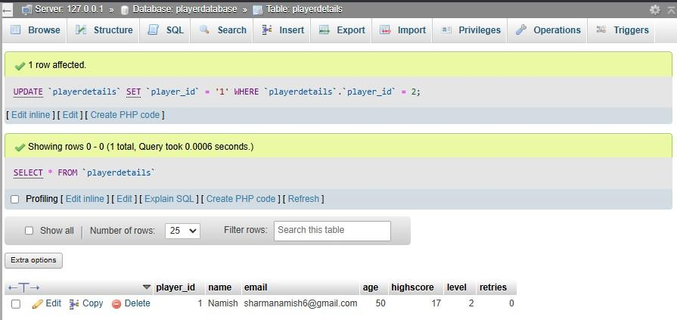
In the same game session, another game is played using the retry button.
If the player's new high score exceeds the previous high score, the SELECT and UPDATE queries are executed.
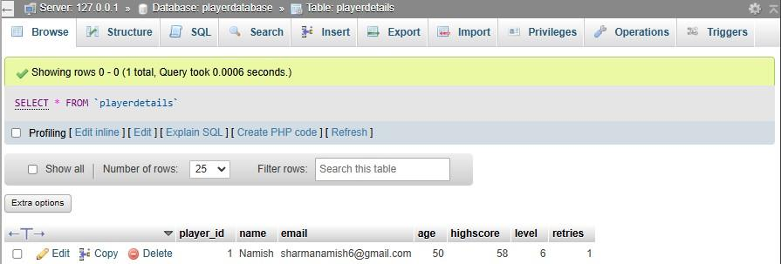
Test 19 | The player in the previous picture surpasses the high score by playing another game session using the Retry button. As a result, the SELECT and UPDATE queries are executed.  
Test 20 | The game is quit, and a new game session is started with different player details. When the player dies, the INSERT query is executed since the SELECT query will not return any results. The second record below shows the new game session.

 | 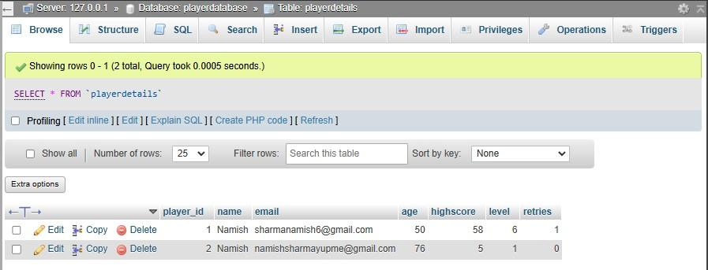
Test 21
Test 22 | The game has a friendly user interface(UI), with clearly labelled buttons and instructions allowing the player to understand the mechanics. The UI elements are consistent in colour, font and size guiding the user to work with the interface accordingly. The screenshots in other test cases cover all of the user interfaces.The pictures below show the UI of the game. Game-menu Phase    Game-active phase


Game-over phase
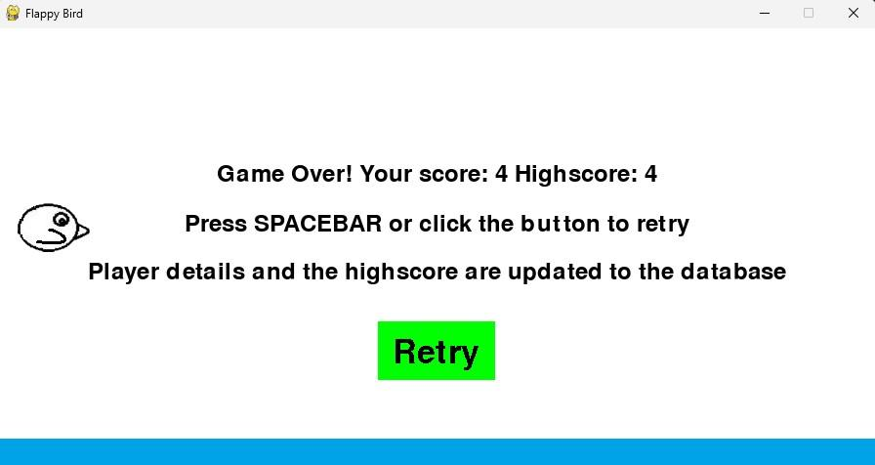
Test 23 | The speed of the poles increases with each level, with each level advancing every 10 points in the score. However, there is a maximum speed limit to ensure the game remains playable. The screenshots show the change in value for speed_multiplier.


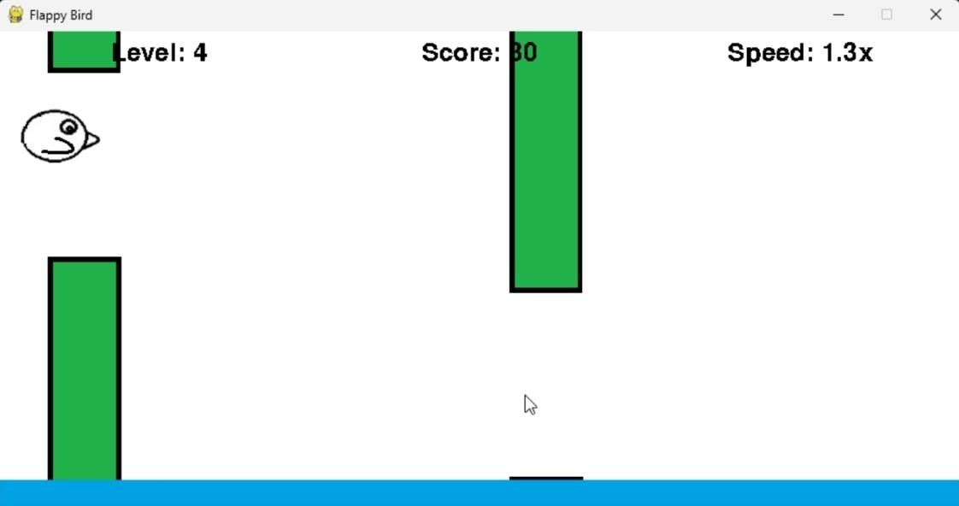
Test 24 | The death screen shows both the score and highscore
 | 
Test 25 | The retry button exists, allowing the player to start the game at will.  

Results of persona testing

Persona Test Cases | Case Tested | Comment
1.Check if Bill has any trouble in the input validation phase to input his data. | ✅ | Bill had no issues with the user interface and could provide accurate data with no errors.
2.Check if Bill can read the instructions and error messages precisely and provide accurate data input. | ✅ | When Bill tried to input incorrect data into the game, the game didn’t start because of issues with how the data was captured. In other words, the program couldn’t properly process the wrong information Bill entered, which prevented the game from loading.
3.Check if Bill can recognize the game menu screen, read the in-game instructions and start playing the game. | ✅ | Bill had no issues in understanding the game logic and reading instructions with ease. The instructions were clear enough to let Bill know what he needs to do next. The option to use either spacebar or mouse button 1 was convenient for Bill.
4.Observe if Bill understands the game mechanics such as controlling the bird and avoiding the poles. | ✅ | Bill initially struggled to understand the gravity mechanics in Flappy Bird but learned to control the bird's flight after one or two retries. Most of his deaths resulted from collisions with the poles rather than hitting the ground.
5.Check if Bill can recognize the game-over screen and navigate to the retry button and retry the game successfully. | ✅ | Bill is able to recognize the game over screen and see his score and highscore after death. He is also able to navigate to the retry button easily.

